INSERT CHURCH NAME WORK HEALTH & SAFETY POLICY

REVISION 2
Dated 20th April 2018

Contents

Contents
Introduction 3
POLICY 4
CODE OF CODUCT 6
SAFE WORK PRACTISES 8
REPORTING TEMPLATES 11
WORKERS / VOLUNTEERS INDUCTION CHECKLIST – Form 01 13
HAZARD REPORTING – Form 02 11
INCIDENT / INJURY REPORTING – Form 03 12
Property and Equipment Audit / Safety Check – Form 04 15
Emergency Plan – Form 05 18
Asbestos Registration – Form 06 19
Grounds and Carpark Guides – Form 07 20
Transport Policy – Form 08 21
Chemical Register – Form 09 22
Electrical Tag and Testing Register – Form 10 23
Food Preparation – Form 11 24
Food Preparation – Form 12 25
Plant Registration – Form 13 26
First Aid – Form 14 27
Building Access Policy – Form 15 28
Sign in / out Sheet – Form 16 29
Key Register – Form 17 30
Complaint Procedure and Policy Document – Form 18 31
Review of WHS Policy – Form 19 35
APPENDIX A - Church Name Food Preparation Guidelines 36
APPENDIX B - How to identify hazardous manual tasks 46
APPENDIX C - Safe use of ladders 50
APPENDIX D - Safe Noise Levels 53
APPENDIX E - First Aid Kits 54
APPENDIX F - Bullying and Harassment 56
APPENDIX G – MENTAL HEALTH AND WELLBEING POLICY 60
APPENDIX H – SMOKE FREE POLICY 61
APPENDIX I – DRUG AND ALCOHOL POLICY 63
APPENDIX J – CONTACT POINTS 65
APPENDIX K – PREPARING AN EMERGENCY PLAN 66

Introduction
This Policy is aimed to help churches prepare their own Church Policy. Work Health and Safety (WHS) Legislation differs between the States of Australia and all Churches are different. In theory there is one National Standard which the States and Territories are then asked to implement. Therefore, this template policy has been written by CCCAust to allow churches to add or subtract portions of the policy as needed to meet local requirements. Please feel free to add or delete as appropriate for your church. At the time of writing this policy NSW, ACT, SA, TAS, QLD & NT had adopted the National Model WHS Act 2011. WA has approval systems in place to use the new harmonized system, but VIC has not committed to implement the national policy. Thus, VIC has a different criteria and captures a wider group of organizations in the must conform to WHS definition than the rest of the States and Territories. See below for the definitions.

The policies and templates developed are quite generic in nature and should be able to be used by all churches in Australia, but it is important that you check against your State based reporting requirements. Appendix G provides contact details for each State and Territory System.

If you have any suggestions or would like to add value to the policy for other churches, please contact Bradley Scott. If you need assistance in adapting this policy to your needs, you may also contact Brad.

Phone (02) 9626 0055
Email brad@cccaustnsw.com

One of the most challenging opportunities facing our churches today is the management of the churches’ health and safety risks. With strict legislative requirements, increasing penalties and the high financial costs associated with workers’ compensation, the consequence of not managing safety risks can be very costly to churches.
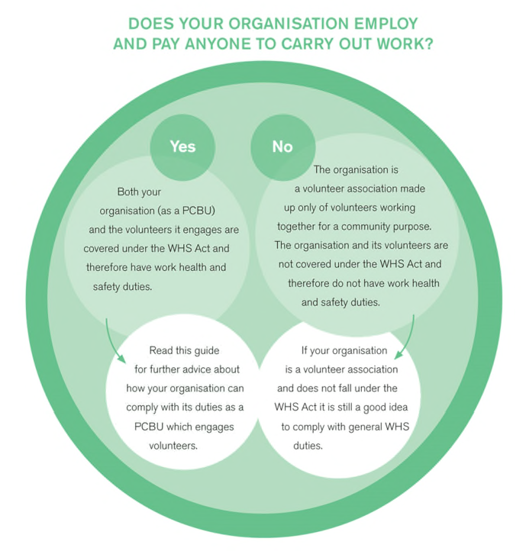
Churches in NSW, QLD, TAS, SA, WA and NT.
Generally, churches that employ staff are covered by the WHS legislation, while those that do not employ staff are not subject to the legislation. However, this does not mean that those churches without paid staff should ignore the requirements of the legislation. As Christian organizations, we have a responsibility before God to provide a safe environment for all who enter our premises, whether they are members, visitors, employees, volunteers, contractors or any other persons. It is a good idea therefore for all churches to implement a WHS Policy and to comply with the WHS obligations of their State or Territory.

Churches in VIC
In VIC WHS applies to organizations as defined above but also captures volunteer organizations if they manage or control a workplace. i.e. Under Victorian WHS laws, a ‘workplace’ is broadly defined as a place, whether or not in a building or structure, where ‘employees’ or ‘self-employed persons work’. Hence, if a church hall is used by self-employed persons (e.g. dance instructors), then it is possible for the WHS laws to apply to all volunteers even if the church does not employ its own staff or pastors.

POLICY

1.1 | TITLE  This policy is called Church Name Work Health & Safety (WHS) Policy.
1.2 | PURPOSE  Church Name is committed to providing a work environment which comply with all relevant Acts and Regulations governing workplace health and safety. It is the intention of Church Name to ensure, so far as is reasonably practical, that all employees, students, contractors and visitors are safe from injury and risks to health while at the workplace and/or while undertaking work-related activities.
1.3 | RESPONSIBILITIES  The Church Elders are ultimately responsible for the implementation and performance of this Policy. A Church Safety Officer will be appointed to manage the Policy in consultation with the Church Elders and will ensure the policy is actioned.  IF A WORKER, CONTRACTOR OR VOLUNTEER SEES SOMETHING THAT THREATENS THE SAFTEY OF ANYONE WITHIN THE CHURCH, THEY SHOULD REPORT IMMEDIATELY TO THE SAFTEY OFFICER, SO THEY CAN IMPLEMENT APPROPRIATE ACTION.  The Church Safety Officer is Phone:  The Church Work Cover Insurer is Policy No:  The Medical Services Provider is Phone:  (Churches are encouraged to appoint a local GP practice as a Medical Services Provider to provide medical advice and aid in an emergency)  The Church Safety Officer will be responsible to process, report and implement safety upgrades as required based on consultation with workers, submitted Hazard Reports or Incident Reports.  The Church Eldership will:  - Ensure the church complies with all legislation relating to health and safety  - Eliminate or minimize all workplace hazards and risks as far as is reasonably practicable  - Provide information, instruction and training to enable all workers to work safely  - Supervise workers to ensure work activities are performed safely  - Consult with and involve workers on matters relating to health, safety and wellbeing  - Provide appropriate safety equipment and personal protective equipment  - Provide a suitable injury management and return to work programs  Workers (Staff and volunteers) will:  - Take reasonable care for their own health and safety  - Follow safe work procedures, instructions and rules  - Participate in safety training  - Report health and safety hazards  - Report all injuries and incidents  - Use safety equipment and personal protective equipment as instructed
1.4 | POLICY STRATEGY  The WHS Policy is maintained through a set of policies and procedures which are structured as follows  - Code of Conduct:  How we treat people and how we expect people to treat others while on our premises  - Safe Work Practices:  Rules to follow when working on our premises. These will apply to  - Employees and Volunteers  - Contractors  - Child Safe Policy  - Child Safe Practices are referred to and maintained in a separate Policy.  Child Safety Officer: Phone:  - The Child Safe Policy and Guidelines will be reviewed every two years and incorporate comments and suggestions from staff, volunteers, parents and the leadership team or as defined in the policy.  - Training and Supervision  Workers and Contractors are to be trained and informed of current policies and procedures.  - Reporting:  We expect Employees, Volunteers, Visitors and Contractors to report  - Hazards  - Incidents (including near misses)  - Workers Compensation and Return to Work.  The church will have in place a Workers Compensation Policy. The church will work with doctors, insurance companies and workers to encourage workers to return to work with modified duties if required after an incident. The Return to Work Co-Ordinator will manage this process.  Return to Work Co-Ordinator: Phone:  - Policy Management  Our policy is a live document and will be reviewed yearly and amended and updated as required to ensure that the safety of Employees, Volunteers, Visitors and contractors is maintained on our premises.
1.5 | IMPLEMENTATION  All employees, volunteers and Contractors will be expected to conform to these policies and procedures. The intent of the Policies will be communicated to Employees, Volunteers and Contractors in two ways.  - Online Induction Course: Covering general policies and guidelines for being safe on our premises. The Online Course will be separated into 2 parts,  - One for Employees and Volunteers  - One for Contractors.  After completing the course online, a certificate will be issued providing proof that the individual has completed the induction course.  - An onsite Induction Course: Covering site specifics such as  - Evacuation procedures and warnings  - Site specific hazards to be aware off (Asbestos etc)  - Site tour  - Site specific access and security issues.

CODE OF CODUCT
The Name Church believes that we as a church are called to reflect God’s character and should act in a way that honors him.
Titus 3:1-2
Remind the believers to submit to the government and its officers. They should be obedient, always ready to do what is good. They must not slander anyone and must avoid quarrelling. Instead, they should be gentle and show true humility to everyone.

As a church, we actively promote:
- A safe environment where abuse of any nature is neither tolerated nor able to take place. The church will actively educate and encourage appropriate behaviour and institute procedures to allow people to report incidents of abuse and have a clear procedure for how these complaints are processed. Areas of abuse may include but not limited to:
  - Bullying: Bullying of any kind is neither tolerated nor able to take place. Bullying can include:
    - Exclusion from a group or activity
    - Intimidation
    - Extortion
  - Harassment: Harassment is neither tolerated nor allowed to take place. Harassment is unwelcome conduct whether intended or not which makes another person feel offended, belittled or threatened. It may occur through a single incident or a series of incidents over a period of time. Harassment can include:
    - Unwelcome physical contact
    - Gestures or language that could give offence including unwarranted shouting
    - Unjustified or unnecessary comments about a person’s attributes or abilities.

See Appendix F for advice on bullying and harassment.

- A safe environment where unacceptable or crude language is neither tolerated nor allowed.

- A safe environment where the abuse of drugs and alcohol is neither tolerated nor allowed. The church property is acknowledged as a smoke free zone and drug free zone. Alcohol is not permitted on the site except for religious ceremonies. See Appendix H for the Smoke Free Policy and Appendix I for the Drug and Alcohol Policy.

- Confidentiality: Confidentiality and trust are fundamental to sound church relationships and must be upheld within the constraints of the law and statutory requirements.

- A safe environment for Children where the church conforms to the State based Working with Children Checks and implements Child Protection policies in conjunction and along with this policy.

- A safe environment where mental health is maintained. The following stress can affect a person’s Mental Health:
  - job demand – the level of physical, mental and emotional effort required to do a job
  - job control – the level of control a worker has over aspects of their work including how or when a job is done
  - support – the level of support from supervisors and co-workers, information, equipment and resources available to allow the work to be done
  - workplace relationships – the nature of relationships between workers, managers, supervisors, co- workers and clients
  - role clarity – the overall scope or responsibilities of the job, clarity about the objectives, key accountabilities and management expectations of workers
  - organizational change management – how change in the organization, structure or job is communicated and the extent of worker involvement during these changes
  - recognition and reward - the nature of feedback on task performance, performance reviews, opportunities for skills development, formal and informal rewards
  - organizational justice – perceptions of unfairness, consistency, bias and respect for workers.

It is important that workers have the right to say no if they feel unsafe and are able to report unsafe behavior or practices. (See Incident Reports). Employment reviews should include questions around these items to ensure these practices are not occurring within the church. To ensure that these behaviors are maintained and effective, Name Church will follow the provide easy access the Incident Reporting process and will handle these submissions in accordance with the Complaints and Procedure Policy.
A Mental Health Policy is attached in Appendix G.

SAFE WORK PRACTISES
The following are well documented safe practices that should be considered and implemented within the church environment:
- Workplace Facilities.
A regular check should be made of the condition of the site to ensure the site is maintained in a safe manner.
See Form 4 – Property and Equipment Audit.
- Emergency plan:
This form should be available to all ministry leaders and responsible people and they should be trained in how to respond in the case of an emergency.
See Form 5 – Emergency Plan
- Asbestos Register:
This form will need to be supplied to anyone doing work on your site if working near Asbestos.
See Form 6 – Asbestos Register
- Carpark and Grounds
Maintenance workers and gardeners should be made aware of these policies and receive training in accordance with the policy.
See Form 4 - Property & Equipment Audit plus operations guides
- Chemicals
Dangerous Chemicals need to be identified and recorded. Those using these chemicals should receive training in the safe use of such.
See Form 4 - Property & Equipment Audit &
Form 9 - Chemical Register
- Confined Spaces:
The Government has a specific code of practice for those who are required to work in confined spaces. The church should ensure that contractors or volunteers who are required to perform work in confined spaces conform to this code of practice.
See Safe Work Australia to access the code.
- Electrical (Tag and Test):
All electrical equipment needs to be checked in accordance with the Governments standard requirements.
See Form 10 – Register of Electrical Appliances
- Fire / Evacuation procedures:
See Emergency Plan
- Food Safety:
Churches do not need to register with authorities to allow them to prepare food for use on site. However, if a church sells food for fundraising purposes, then they need to comply with the guidelines. Furthermore, if a church sells food as a business, then they need to be registered and conform with the relevant legislative requirements. All churches should implement policies that conform to the National Standard for food safety. A set of guidelines are included in Appendix A for churches to consider and Form 12 should be signed by those responsible for preparing and maintaining food standards in the church. A list of those who have signed the forms should be recorded on Form 11.
See Form11 & 12
- Lift:
Under the Governments laws, certain plant and equipment need to be registered with State Authorities. Lifts are one of these items. If your church has a lift you need to keep records of the annual inspections and submissions to your local authorities. During maintenance operations, safety processes need to be adhered to, to ensure no one can fall into the lift well or access areas of danger during the service.
See Form 13 – Plant Registration.
- Manual Handling (lifting etc):
A hazardous manual task, as defined in the WHS Regulations, means a task that requires a person to lift, lower, push, pull, carry or otherwise move, hold or restrain any person, animal or thing involving any, or a combination, of the following:
  - repetitive or sustained force
  - high or sudden force
  - repetitive movement
  - sustained or awkward posture
  - exposure to vibration.
These factors (the characteristics of a hazardous manual task) directly stress the body and can lead to injury. Australian Workers’ Compensation Statistics 2012-13 attributes 45% of all serious workers’ compensation claims to injuries of joints and adjacent ligaments, muscles and tendons. Muscular stress while lifting or handling objects accounted for 33% of serious claims in the period 2012–13. It was identified as one of eight priority occupational disease groups under the National OHS Strategy. Appendix B proves an overview of how to assess this risk in your church setting, where the assessment can be recorded on Form 2.
See Form 2
- Falls / Working at Height / Ladders:
Each year slips, trips and falls result in thousands of preventable injuries. The most common ones are musculoskeletal injuries, cuts, bruises, fractures and dislocations, but more serious injuries can also happen. Over the 12 years between 2003–15, slips, trips or falls:
  - caused the death of 386 workers
  - led to 23% of serious claims
  - were caused by environmental factors 56% of the time.
Environmental factors can include slippery surfaces following rain or spills, poorly designed or maintained walkways, poor lighting on stairs and walkways and trip hazards for example from poorly stored materials. These items will be covered by the regular site checks in accordance with Form 04. The use of ladders need to be considered and Appendix C provides some basic rules to be followed when using a ladder.
See Form 04
- Noise:
Noise at the workplace that exceeds the exposure standard (85 decibels averaged over an 8-hour period) can lead to temporary or permanent hearing loss. This hearing loss is a result of the hair cells in the inner ear being permanently damaged – and once they are destroyed, they never grow back. Damage to hearing usually happens over a number of years and is known as noise induced hearing loss (NIHL). It is a permanent condition that can have a negative impact on your life. Some loud noises, such as explosive powered nail guns, firearms, stamping presses and forges, can damage your hearing instantly. This is known as acoustic trauma.
Employers, have specific obligations under the WHS Regulation. You must:
  - make sure the noise a worker is exposed to at the workplace doesn't exceed the exposure standard for noise.
  - provide audiometric testing to workers who are frequently required to use personal hearing protection. See Appendix D
- First Aid Facilities:
Churches are required to ensure they
  - provide appropriate first aid equipment for the workplace
  - locate the First Aid in a place that it is easily accessible for use of staff and volunteers
  - have appropriate access to the workplace for emergency teams to provide aid
  - have an adequate number of staff and volunteers trained who can administer first aid or provide access to an adequate number of other persons who have been trained to administer first aid.
When assessing the first aid requirements for the church, the following should be considered.
  - the nature of the work being carried out at the workplace;
  - the nature of the hazards at the workplace;
  - the size and location of the workplace;
  - the number and composition of the workers and other persons at the workplace.
See Forms 04 &14 and Appendix E to help manage these requirements.
- Security: Security:
The Church is responsible to ensure that it has procedures in place to
  - ensure the property is locked and unlocked in an appropriate manner.
    - An unlock / lock up procedure should be maintained. See Form 15
  - record visitors and contractors who enter the site. See Form 16
    - Children’s programs should maintain a record of staff, volunteers, children in attendance in accordance with Child Protection Policy.
  - Maintain a key register defining who has access to the property. See Form 17
  - Report on any thefts or property damage using Form 03 and review and look into changes of policy that may reduce these events from occurring in the future.
  - Check that warning systems are functional and conform to legislation. i.e. Back to base Alarm and Fire Warning systems.
These procedures should be reviewed yearly and are the responsibility of the Safety officer. Some considerations look at when assessing the security of the church.
  - Security Alarm
  - Good External Lighting
  - Security Cameras
  - Signage identifying Security Measurers
  - Physical Barriers such as grills on Windows

REPORTING TEMPLATES

Hazards (See Hazard Reporting - Form 02)
When a person identifies a hazard, they are to report it as soon as possible to the Church Safety Officer. The Safety Officer is responsible for conducting a hazard investigation and risk assessment using the Hazard Reporting Form (Form
- and for then developing a control strategy for the hazard.

Incidents (See Incident / Injury Reporting Form - Form 03)
When an incident occurs (including property damage and/or near miss), the person(s) involved are to seek medical attention (if required) then notify the Safety Officer. The Safety Officer in consultation with the person(s) involved is to document the incident using the Incident / Injury Reporting Form. The Safety Officer must notify the Pastor and/or Elders as soon as practicably possible. The Safety Officer is then responsible for conducting an incident investigation using the Incident / Injury Reporting Form (Form 03) and for developing a control strategy for any associated hazard.

When to Report to Regulators
The Act requires certain types of workplace incidents to be notified to regulators. Only the most serious safety incidents are intended to be notifiable and they trigger requirements to preserve the incident site pending further direction from the regulator.
Notifiable incidents are:
  - the death of a person
  - a ‘serious injury or illness’, or
  - a dangerous incident arising out of work carried out by a business, undertaking or a workplace. Notifiable incidents relate to any person—whether an employee, contractor or member of the public.
If a notifiable incident occurs the model WHS Act sets out that:
  - immediate notification of a ‘notifiable incident’ to the regulator, after becoming aware of it
  - if the regulator asks—written notification with 48 hours of the request, and
  - preservation of the incident site until an inspector arrives or directs otherwise.

Policy Management Procedures
A yearly review using Form 19 should be held with appropriate stake holders to ensure the document is updated.

Induction Courses
Induction is completed in two stages where contractors, Staff and Volunteers do an online general course covering general WHS topics. This will be followed up on site with a site-specific induction course.

Workers and Volunteers Online
- Code of Conduct
- Safe Practices General Information
- Reporting expectations
  - Hazards
  - Incidents
- Feedback on observed safety issues

Workers and Volunteers Onsite
Provide a checklist for site Induction
- Check they have an online induction card
- Site Tour
- Warning signals (Fire)
- Site specific Hazards (Asbestos)
- Evacuation point
- Security Measures if required (alarm codes, lift usage etc)
- Information re any equipment specific to their role from policies (ie lawn mower safety from carpark and Grounds Policies.)

Contractors Online
- Code of Conduct
- Safe Practices General Information and requirements to conform to legal and ethical boundaries in accordance with their trade / employment
- Reporting expectations
  - Hazards
  - Incidents
- Feedback on observed safety issues

Contractors Onsite
Provide a checklist for site Induction
- Check they have an online induction card.
- Site Tour
- Warning signals (Fire)
- Site specific Hazards (Asbestos)
- Evacuation point
- Security Measures if required (alarm codes, lift usage etc)

WORKERS / VOLUNTEERS INDUCTION CHECKLIST – Form 01

(Place Logo / Header here)
Church Name Induction Checklist

Worker Name:
Position: (Staff, Volunteer / Contractor)
Task Specific Training Required:
Has Online Induction been completed? YES  NO 
WHS INDUCTION REQUIREMENTS | Carried out at induction |  | If No – date to be covered
 | Yes (tick) | No (tick)
Show Staff amenities location etc
WHS Policy and procedures
Organisation and worker obligations
Repair and maintenance procedure
Hazard report form
Incident report procedures
Drug and alcohol and smoking policy
Bullying and Harassment
Emergency procedures
First aid
Specific work-related hazards
Issue security key and show open and lock procedures
Safe work procedures – specific training provided
Risk Management
Hazardous substances and SDS
Working at External locations
Comments:
I have discussed and confirm that I understand all the above requirements:
Worker Signature: | Date:
Induction carried out by: | Date:
Please note this list is not exhaustive – each provider would need to look at their organisation, structure and work practices and amend accordingly

HAZARD REPORTING – Form 02

(Place Logo / Header here)
Church Name Hazard Reporting Form

Completed by Ministry Leader
Name of person reporting problem:

Time: Date: / /

What is the problem?

Has any short-term measure been taken to resolve problem? (e.g. erect barrier etc.) – describe:

What further action is required?

Signed: Date: / /

Completed by Safety Officer

Action taken to rectify problem:

Action completed by: | Date: | / /
Managers Signature: Copy of form returned to person(s) raising issue: Yes  Monitoring that control measure effective: Yes | Date:  □  □ Date: | / /  / /

INCIDENT / INJURY REPORTING – Form 03

(Place Logo / Header here)
Church Name Incident / Injury Reporting Form

To be completed for ALL incidents and accidents where an injury has or could have resulted.
Work Location:  Organisation Facility In the Community  Other | Today’s Date:  / /
Status of involved person:  Employee Supported employee/client/resident Visitor Volunteer Contractor | Outcome:  Hazard Near Miss  Lost Time Injury Medical Treatment Injury  First Aid
Details of involved person:

Surname: First name: DOB: / / Home Address: Phone:
Sex: M / F
Details of witnesses (if any):

Name: Phone: Address:

Name: Phone: Address:
Details of incident or accident:

Date: / / Time of Injury: AM / PM

Activity engaged in at time of incident:

Exact location of person at time of incident: Describe how and what happened (please give full details & include a diagram, if appropriate. Use a separate sheet if necessary. Please include car registration number if reporting a Motor Vehicle Accident).
Details of injury if applicable: (supervisor may need to assist completion) Cause of Injury:
Lift/bend/push/pull object Psychological/Stress – Bullying / Harassment Surface/Material or Sun Exposure
Lift/bend/push/pull person Psychological/Stress -Workload / Organisation Electric Shock Static or Repetitive Posture or Arm Usage Hazardous Substance/ Material Hand Held Tools
Workplace Violence Biological Agency Contact with Animal / Insect
Slip/Trip/Fall Indoors Entrapment in Equipment/Machinery Vehicle Accident – Work Vehicle Slip/Trip/Fall Outdoors Strike/Struck by Equipment/ Machinery Vehicle Accident - Own Vehicle Superficial if not cause by above Involuntary Movement of client Behaviour of client
Other:

Nature of injury/illness (e.g. burn, sprain, cut etc.)

Location on body (please circle and specify):
How injury occurred (e.g. fall, grabbed by person, muscular stress): What caused the injury (e.g. furniture, another person, hot water):
Treatment administered if required: Yes No

Treatment: Referral required: Yes No Who to: First aid attendant (Print Name): Signature:
THE FOLLOWING SECTIONS ARE TO BE COMPLETED BY THE SAFETY OFFICER
Incident or accident investigation:
Did the incident occur as part of the involved person’s normal activities? Yes □ No □ N/A □
Did equipment contribute? Yes □ No □ N/A □
Was the equipment used designed for activity? Yes □ No □ N/A □
Was the equipment properly maintained? Yes □ No □ N/A □
Did the equipment fail? Yes □ No □ N/A □
Had a risk assessment been undertaken? Yes □ No □ N/A □
Did safety instructions accompany activity? Yes □ No □ N/A □ Are there documented safe work procedures (SWP) for activity? Yes □ No □ N/A □ Were these Safe Work Procedures followed? Yes □ No □ N/A □
Was appropriate PPE used? Yes □ No □ N/A □
Was the involved person trained in this activity? Yes □ No □ N/A □
Did a known behaviour problem contribute? Yes □ No □ N/A □
Was there a known behaviour management plan? Yes □ No □ N/A □
Was it followed? Yes □ No □ N/A □
Did poor housekeeping contribute? Yes □ No □ N/A □
Did the work environment contribute? Yes □ No □ N/A □

After reviewing the above prompts and through interview/site visits what is the identified cause(s):

Remedial actions recommended:

Conduct task analysis Re-instruct persons involved Improve design/construction / Guarding Conduct hazard systems audit Improve skills Mix Add to inspection program
Develop/review task procedures Provide debriefing and / or counselling Improve communication / reporting procedures
Improve work environment Request Maintenance Improve security
Review OHS policy/programs Improve personal protection Temporarily relocate employees involved Replace equipment/tools Improve work congestion / Housekeeping Falls Prevention Assessment
Improve work organisation Investigate safer alternatives Request MSDS Develop and/or provide training Other (specify)
What, in your own words, has been implemented or planned to prevent recurrence:
Remedial actions completed:

Signed (Safety Officer): Title: Date: / /
Did the injured person stop work: Yes No
If yes, state date: / / Time: AM / PM Outcome:
Treated by Doctor Lodged workers comp claim Contacted by RTW Coord
WorkCover notified Insurer notified Returned to normal duties
Returned to modified duties Hospitalised OHS Committee/reps advised
Elder’s review Comments:

Signed: Date: / /

Property and Equipment Audit / Safety Check – Form 04

(Place Logo / Header here)
Church Name Property and Equipment Policy
Name Church is committed to providing safe spaces for workers, volunteers and children to participate in organised activities. The following audit will be completed on a six-monthly basis. If an incident report involves the need to modify a portion of the property, then that item will be added to the six-monthly check list.
(Churches will need to add or subtract from this suggested checklist to mirror their churches requirements)
Date: | - / ✗ | Comments / Actions
A. Car Park / Entry
i. Clean / Clear of Rubbish
ii. Disable Access available
iii. Pathways clear of obstacles and
non-slip.
iv. Signage in good condition
v. Disability Parking clearly marked
vi. Check traffic controls in place and working
B. Aisles / Corridors
i. Surfaces clean / clear of defects
ii. Clear of rubbish
iii. Clear of electrical leads
iv. Clear vision at intersection
v. Clear of spillages
C. Floors
i. Even surfaces – no holes
ii. Clear of rubbish
iii. Clear of trip hazards
D. Steps / Stairs
i. Highlighted
ii. Handrails
iii. Ramps for disable access
iv. No steps are too high
E. Windows
i. Clean and Clear
ii. No broken Windows
iii. Windows free of rubbish and
obstruction
iv. Windows open freely (if openable)
F. Ventilation
i. Does AC work efficiently
ii. Have filters been cleaned?
iii. Is adequate ventilation occurring
G. General Lighting
i. Adequate illumination / bulbs all
working
ii. Good natural light
iii. No direct or reflected glare
H. Fire / Emergency
i. Extinguishers in place, services
clearly marked
ii. Fire hoses / blankets in place with correct signage
iii. Exit signs operational and clearly
visible
iv. Exit doors freely open from inside
v. Exists free from obstructions
vi. Fire alarm systems in place /
regular tests and documentation of such
vii. Emergency evacuation procedures displayed
appropriately
viii. Deadlocks on emergency doors able to be overridden in case of
emergency
ix. Telephone available in case of
emergency
x. Emergency services numbers
displayed clearly.
I. Electrical
i. Equipment not in use stored
correctly
ii. No broken plugs, sockets or
switches
iii. No frayed or defective leads
iv. No temporary leads left on floors
v. Unserviceable equipment tagged
with fault listed
vi. Electrical installations are installed, constructed, maintained, protected and tested to minimise risk of electrical
shock or fire.
vii. Handheld portable equipment is
protected by RCD (Residual Current Device)
viii. Flexible extension cords are used in a safe manner, Connections are moulded or transparent
plugs.
ix. All leads are tag and tested.
J. First Aid
i. Cabinets and contents clean and
orderly
ii. No unauthorised items available
eg Panadol / matches
iii. Emergency Numbers displayed
iv. Has First Aid register for first Aid
officers been updated - Form 13
K. Rubbish
i. Adequate amount of bins
ii. Bins located in suitable points
iii. Bins emptied regularly
L. Hazardous Substances
i. All hazardous substances (not poisons) are properly labelled
and stored correctly.
ii. People who are exposed to hazardous substances have been provided with adequate
information on safe use
M. Toilets
i. Adequate number of toilets
available
ii. Disable access to toilets
iii. Toilets clean and clear of rubbish
iv. Cubicle door locks can be
overridden in case of emergency
v. Poisons locked away
vi. Floors clean / non slip
vii. Drains inaccessible to children
N. Kitchen / Food Preparation
i. Poisons locked away
ii. Plastic bags locked away
iii. Appliances inaccessible to
children
iv. Cutlery inaccessible to children
v. Glass items inaccessible to
children
vi. Hot water inaccessible to children
vii. No dangling cords
viii. Floors dry / non-slip
ix. Safety plugs used in power points
x. All matters of hygiene considered
xi. Hand washing soaps accessible
O. Outside / Building External
i. Fences in good condition
ii. Gates and locks working
iii. Equipment locked away
iv. Dangerous plants removed or
made safe
v. Play equipment appropriate and
safe to use
vi. Perimeter fire breaks clear and
serviceable
vii. Exterior of building clean and free
of damage.
viii. Lawn equipment in good order (See Procedures for lawn
mowing)
P. LIFT
i. Work Cover permits current
ii. Emergency Phone working
iii. Emergency signage in place
Q. Other Areas of Concern Identified but
not listed.
i. Ladders in good condition with
non slip base.

Name of Checker:
Signature: |  | Date:

Emergency Plan – Form 05

(Place Logo / Header here)
Church Name Emergency Plan

Diagram - Site Plan with Emergency Exits and Evacuation Point
Emergency Contact
Emergency Numbers: 000 (Ambulance, Police, Fire Brigade) What you need to provider to Emergency Services:
Specify which service you need | AMBULANCE, POLICE, FIRE BRIGADE
Your Suburb:
Street Name and Number:
Nearest Cross Street:
Emergency vehicle access point:
Phone Number you are calling from:
First Aid Officer
Emergency Vehicle Meeting Point: (Ask a co-worker to meet the service
at the following location)
Access:
- For rural addresses or locations hard to find, have someone wait outside the building/location to wave the ambulance down.
- Leave the front light on at night or use marker ribbons, vehicle hazard or other lights to indicate entry gate or incident site.
- Clear hallways of obstructions to allow the services easy access.
- Reserve goods and services lift if required for stretcher access.
- Advise your receptionist that an ambulance has been called. Reception telephone number:

Safety Office Name: Safety Office Phone Number:
(See Appendix H for help in developing this sheet)

Asbestos Registration – Form 06

(Place Logo / Header here)
Church Name Asbestos Registration Form

Asbestos was once used in Australia in more than 3000 different products, including fibro, flue pipes, drains, roofs, gutters, brakes, clutches and gaskets.
Breathing in asbestos fibres can cause asbestosis, lung cancer and mesothelioma. The risk of contracting these diseases increases with the number of fibres inhaled, and the risk of lung cancer from inhaling asbestos fibres is also greater if you smoke.
Those who get health problems from inhaling asbestos have usually been exposed to high levels of asbestos for a long time. Symptoms don’t usually appear until 20 to 30 years after initial exposure.
If asbestos fibres are in a stable material, such as fibro, they pose little health risk. However, when the fibro is damaged or disturbed in some way, fibres can become loose and airborne, and pose a risk to someone’s health.
If your workplace was built before 31 December 2003, you must keep a register that outlines when and where asbestos has been located, what type it is, and what condition it’s in.
Make the register available to anyone likely to be exposed to asbestos, keep it up-to-date, and pass it on to anyone who takes over management or control of the workplace.

CHURCH NAME  ADDRESS |  |  | Name of competent Person
Date of  Identification | Type of asbestos | Is it friable or  non-friable? | Condition of  asbestos | Specific location  of asbestos | Is this an  inaccessible area?
1/02/2012 | AC Roof Sheeting | Non-Friable | Good, minor deterioration on  western end | Whole Roof | Not easily

Grounds and Carpark Guides – Form 07

(Place Logo / Header here)
Church Name Grounds and Carpark Guides

Lawnmower, Edger’s, Trimmers and Blowers Guides
This equipment can only be operated by a trained and authorised employee of the company. Equipment must NOT be altered or modified without authorisation.
SAFETY INSTRUCTIONS
- Check the general condition of the equipment. Check with supervisor if unsure.
- Check that the blades are sharp, secure and not damaged. Check with supervisor if unsure.
- Do NOT operate the equipment without all guards in place.
- Check all switches, controls and emergency stops before use.
- Check area to be mowed for possible debris that may be thrown.
- Avoid mowing areas where there is potential for endangering people and animals.
- Maintain a proper balance and secure footing when starting the mower.
- Always mow in a forward direction.
- Mow across any slope to avoid contact with a mower that may slip.
- Operate at a speed that ensures control over unexpected hazards.
- Wear a broad brim hat and apply sunscreen on high UV days.
- Assistants working with you must also wear hearing and eye protection.
- Keep hands/fingers away from mover blades and moving parts.
- Confine loose clothing and long hair.
- Minimize stooping and bending when using equipment.
- Turn mower off and remove spark plug lead to perform maintenance; clear grass clogs; and to clean down. Avoid touching hot surfaces.
- NEVER leave a mower running and unattended.
- NEVER run a mower in confined area. Beware of exhaust fumes.
- Allow mower to cool before refueling. Use only approved fuel containers. Do NOT decant fuel to unmarked containers.
- Avoid all sources of ignition when refueling.
- Wash hands after handling fuel and oil.
- Report all equipment faults and hazards to the supervisor.
CAUTION - Beware of contact with blade; flying objects and debris; mowing over debris and other objects; loud noise; UV hazards; and fire hazards caused by fuel.

Transport & Traffic Control
All workers, staff, contractors and visitors shall be responsible for:
  - Reporting any traffic hazards to the Church leadership
  - Complying with procedures regarding traffic management. The Church leadership shall be responsible for:
  - Ensuring that there is an effective traffic management plan in place, covering, where appropriate:
    - Separation of vehicles, pedestrians and other church traffic from each other
    - The use of physical barriers to separate pedestrians from traffic
    - Traffic management and warning signs
    - Traffic direction
  - Identification of all areas where vehicles and pedestrians could come into conflict by carefully studying vehicle and pedestrian movements and providing clearly marked “No Go” or exclusion zones for both pedestrians and vehicles
  - Adequate and well-located parking for disabled persons
  - A “right of way” procedures and clear indications where and when pedestrians and vehicles have right of way
    - Ensuring action is taken to remove or minimise any identified hazard
    - Ensuring that all operators of Church vehicles are properly trained and licensed
    - Ensuring traffic areas are well illuminated at night (if applicable).

Transport Policy – Form 08

(Place Logo / Header here)
Church Name Transport Policy
Drivers with responsibility for providing transportation during an activity are required to complete this form. Applicant:
Drivers Name: Phone No: I have a current Driver’s License: Yes No □ Expiry Date:
□
□
□

Type of License: Car
Bus □ Other (please specify)

I have sufficient driving experience (3 years min and are not on my L’s or Red P’s) Yes No
□
□
□
□
I have restrictions on my License (eg Green P’s, suspended license): Yes No
If so please specify:

Witness:

License sighted by : Signature: Dated:

Declaration:
- I have completed all screening requirements for XXX Church, in relation to my suitability to work with children
- I will not drive a child will alone.
- I will drive carefully and follow all road rules. (This approval will be revoked if inappropriate behaviour is witnessed at any time in your vehicle)
- I will provide a registered, roadworthy vehicle
- I will ensure that all passengers wear a seat belt
- I will not drive under the influence of alcohol or drugs, or permit smoking within the vehicle
- I have a good driving record. Specifically, I have not committed traffic offences in the recent past which might reasonably preclude me from transporting participants. I will discuss this with my team leader prior to offering myself to drive if unsure.
The information provided on this form is correct and indicates my commitments to the safety and welfare of those for whom I am responsible.

Signed: Dated:

Chemical Register – Form 09

(Place Logo / Header here)
Church Name Chemical Register
All hazardous chemicals that are stored, handled or used at a workplace must be listed on the register except where they are:
- in-transit
- consumer products.
Hazardous chemicals are in-transit if they are not used in a workplace and are not kept there for more than five consecutive days. However, where a workplace frequently has in-transit hazardous chemicals present—or they are present in significant quantities—these should be listed on the register.
Consumer products are those that are packed primarily for use by a household consumer and are used in a way that is consistent with normal household use.
- For example, laundry detergent packed in a 1 kg container and used once a week by individual staff for washing work clothes is considered a consumer product and would not need to be included on the register. But a 30 kg container of the same detergent used by a commercial laundering business is not considered to be a consumer product and must be included on the register.
Consumer products also include hazardous chemicals used in an office, for example printer toner and whiteboard cleaners.
Chemicals that are not hazardous do not need to be included on the register.

Name of Chemical | Location of Chemical | Current SDS  Yes/No | Issue date of  SDS | Hazardo us  Yes / No | Quantity | Risk Assessment  Yes / No | Uses

Electrical Tag and Testing Register – Form 10

(Place Logo / Header here)
Church Name Electrical Tag and Testing Register
Certain types of electrical equipment must be regularly inspected and tested by a competent person to identify damage, wear and detect electrical faults.

You must make sure that electrical equipment is regularly inspected and tested by a competent person if the electrical equipment:
  - is supplied with electricity through an electrical socket outlet ('plug in' equipment), and
  - used in an environment in which its normal use exposes the equipment to operating conditions that are likely to result in damage to the equipment or a reduction in its expected life span, eg conditions such as exposure to moisture, heat, vibration, mechanical damage, corrosive chemicals or dust.

'Competent person' for inspection and testing
A competent person is someone who has acquired - through training, qualification or experience - the knowledge and skills to carry out inspections and testing of electrical equipment.
The relevant Australian standards are:
  - AS/NZS 3760: 2010 - In service safety inspection and testing of electrical equipment, outlines inspection, testing and tagging methods
  - AS/NZS 3012: 2010 - Electrical installations - Construction and demolition sites, outlines regular inspection and testing requirements.

Regular testing requirements
Electrical equipment for churches should be tested at a minimum of every 5 years.

Record of testing results
A record of testing must be kept until the electrical equipment is next tested, permanently removed from the workplace or disposed of. A record of testing must specify:
  - the name of the person who carried out the testing
  - the date of the testing
  - the outcome of the testing
  - the date on which the next testing must be carried out.
The record may be in the form of a tag attached to the electrical equipment tested.

Workplace
Plant ID  number | Equipment description | Location | Date tested | Passed  /failed | Record of repair  / comments | Signature of tester | Due date

Food Preparation – Form 11

(Place Logo / Header here)
Church Name Food Preparation Guidelines
Church life is often about community and as part of community we tend to share meals. The latest figures published by the Food Safety Information Council (as of 2014) estimated 4.1 million cases of food poisoning occur in Australia each year including 31,920 hospitalisations, 86 deaths and 1 million visits to doctors.

As churches we need to ensure we follow safe food handling practices to reduce the possibilities of adding to the above figures. According to the legislative bodies, depending on whether we sell food (fundraising) or not will influence what rules we need to conform to.
For Guidelines associates with preparing food in a church, please see Appendix A This guide is aimed at providing advice to churches who
- Prepare food for use on site at a church but do not sell the food.
- Prepare food for sale at a fundraising event
If your church runs a café or sells food as part of it’s business, then you’ll need to seek alternative advice to ensure you conform to the legislative requirements.

Food Preparation Personal Register
The following people have returned a signed form confirming that they have read and understood the Food Preparation Guidelines for Church Name. It is understood that those who have signed this form are the team leaders and people responsible for the food preparation and that they will ensure and take the responsibility for those who volunteer and help out in preparing the food, that they understand appropriate behaviour and hyenine requirements and will ensure the volunteers who work with them are aware of these matters also.

Name | Date Received

Food Preparation – Form 12

(Place Logo / Header here)
Church Name Food Preparation Guidelines

I have read the Church Name Food Preparation Guidelines (As recorded in Appendix XX) and agree to monitor and implement these guidelines while I prepare and serve food for the church.

I will also monitor the practices of others around me and ensure that my team and volunteers understand and use good hygiene and food practice methods when preparing and servicing food.

Print Name Date: \ .\

Signed:

Plant Registration – Form 13

(Place Logo / Header here)
Church Name Plant Registration
Plant:

Certification No:

Maintenance Schedule – Service type | Company to Service | Date

First Aid – Form 14

(Place Logo / Header here)
Church Name First Aid

Please ensure a copy of this form is placed on top or fixed to the First Aid kit. Emergency Numbers: 000 (Ambulance, Police, Fire Brigade)
What you need to provider to Emergency Services:
Specify which service you need | AMBULANCE, POLICE, FIRE BRIGADE
Your Suburb:
Street Name and Number:
Nearest Cross Street:
Emergency vehicle access point:
Phone Number you are calling from:
First Aid Officer
Emergency Vehicle Meeting Point: (Ask a co-worker to meet the service
at the following location)
Access:
- For rural addresses or locations hard to find, have someone wait outside the building/location to wave the ambulance down.
- Leave the front light on at night or use marker ribbons, vehicle hazard or other lights to indicate entry gate or incident site.
- Clear hallways of obstructions to allow the services easy access.
- Reserve goods and services lift if required for stretcher access.
- Advise your receptionist that an ambulance has been called. Reception telephone number:

Activity | First Aid Person | Mobile | Training Valid  until | Date  Added | Date  Removed

Building Access Policy – Form 15

(Place Logo / Header here)
Church Name Building Access Policy
Below is a list of procedures to consider when accessing the building
- Door to be used to access the building
- Deactivate the alarm
- Turn on lights and open other areas of access
- Turn on AC or ventilation devices

Below is a list of procedures to consider when leaving the building
- Ensure AC and lights are off
- Ensure all personal have vacated the building
- Set the Alarm
- Leave the building

Sign in / out Sheet – Form 16

(Place Logo / Header here)
Church Name Visitor / Contractor Sign in / out

Churches may have different policies for different activities to record who is on site at any time. For example, if you have an attendance list for church services, that would cover these needs
If you are running a Children’s Activity where the parents are not on site, then the Child Protection Requirements and forms should be used to maintain attendance records of both Staff, Volunteers and children.

Where you have activities during the week which are not covered by these requirements, a sign in sheet should be used to record who is on site and why they are there. This would include contractors who need to be inducted onto the site or people who visit the site for meetings or other requirements.

Date | Time of  Arrival | Name | Purpose of Visit  Who you are Visiting | Time of  Departure

Key Register – Form 17

(Place Logo / Header here)
Church Name Key Register
The Church should have a register of people who have access to the property.

Key Number | Name | Date Issued

Complaint Procedure and Policy Document – Form 18

(Place Logo / Header here)
Church Name Complaint Procedure

Overview:
Church Name is committed to ensuring that the church and its operations are conducted with excellence. Church Name recognises that there may be times when issues arise that require Church Name to resolve difficulties, grievances and complaints in a prompt, and equitable manner. The procedure sets out the process by which this will occur.
Purpose:
The purpose of this procedure is to:
- provide guidance in the handling of complaints;
- provide a process where complaints are handled consistently, equitably, and ensuring privacy; and
- inform staff and leaders of their responsibilities regarding handling of complaints.
Church Name is committed to the early and informal resolution of complaints. Complainants should attempt to resolve complaints in an informal way with the person directly involved.
Definitions
Term Definition

Bullying See Appendix F

Complainant The person/s that has lodged, or is considering lodging, a grievance or complaint.

Duty of Care To do everything reasonably practicable to protect others from harm

Informal The initial stage of the complaints procedure. A complainant should attempt to resolve complaints at this stage of the process.

Formal If the complaint is unable to be resolved at the informal stage a formal complaint can be made.

Respondent The person responding to the complaint, ministry leader, senior pastor or Church Elder

Unlawful An action in relation to matters prohibited by law

Vulnerable people People who do not have the ability to advocate for themselves, are less able to protect themselves or are at risk of harm.

Complaints Procedure:
Church Name seeks to resolve issues, difficulties, grievances and complaints in a prompt, impartial and just manner. Complainants should attempt to resolve complaints in an informal way with the person directly involved. The method of resolving complaints will differ depending on the specifics of the complaint. The complaint may be informal or formal in nature. All parties involved in a complaint must participate in the resolution of the matter in good faith. Leaders and members of the church are expected to conduct themselves in line with biblical principles. All parties involved are to be treated with respect and impartiality. The principles of natural justice should be observed. This includes that the matter will have a fair hearing and to have a decision made by an unbiased decision-maker. The Church will abide by legislative responsibilities at all times. This includes reporting to authorities when appropriate.

Informal Complaint Process
A complaint can be made in different ways e.g. in person, by telephone, in writing, online. Where possible a complainant is to raise the matter directly with the relevant Ministry Leader as soon as practicable. If the matter involves allegations of, or suspected abuse, the matter is to be directly referred to the Safety Officer using the Incident form or if appropriate the Child Protection Reporting forms. The safety Officer will take the appropriate steps under their formal responsibilities. This notification should occur as soon as practicable.
The preferred method of communication of these matters is in person. Matters can be raised through the identification of red flags by a team leader, via a third party sharing concerns with a team leader or through direct disclosure to a team leader from the person. The team leader will:
- Receive Complaint: Listen to the complainant and provide advice on options available to the complainant, including providing advice on managing the matter themselves;

- Assess Risks: The team leader should assess the complaint and if necessary (abuse) refer the matter to the Safety Officer and fill in an Incident form. Otherwise
- Manage the Complaint: To manage the complaint
  - Acknowledge the complaint: Respond seriously and impartially and deal with the complaint promptly. Advise the complainant and respondent of the responsibilities of all parties as outlined in the WHS Policy.
  - Maintain the confidentiality of the complaint, consider the wishes of the complainant wherever possible, but this may not include taking no action where duty of care requirements need to be considered;
  - Gather Information:
    - Seek a response to the allegations from the respondent.
    - Provide copies of relevant policies and procedures, if needed;
    - Ask the complainant:
      - What other avenues they have explored to try and resolve the matter,
      - What action they are requesting, and
      - What expectations they have for an outcome;
    - Examine the complaint and the response.
    - Pursue any questions and speak to other relevant parties (Check the facts)
    - Evaluate any relevant documents and information and consider mitigating factors
    - Seek advice from a more senior leader if unsure
- Resolve: Propose a resolution, where appropriate, with input from the complainant and respondent; and
- Implement: Implement or facilitate the implementation of the resolution, if appropriate.
- Record Keeping: Document and keep on file the outcomes of the agreed resolution.

Formal Complaint Process
If the complainant is unsatisfied with the outcome of the informal complaint, they can submit a formal complaint to the Church Elders. To activate a formal complaint, the complainant needs to have completed the informal complaints process first.
If the matter involves allegations of, or suspected abuse, the matter is to be directly referred to the Safety Officer so they can implement appropriate procedures. This notification should occur as soon as practicable. The preferred method of communication of these matters is in person. Matters can be raised through the identification of red flags by a team leader, via a third party sharing concerns with a team leader or through direct disclosure to a team leader from the person.
The Safety Officer will work with the Elders to:
- Manage the Complaint: To manage the complaint
  - Acknowledge the complaint: Respond seriously and impartially and deal with the complaint promptly. Advise the complainant and respondent of the responsibilities of all parties as outlined in the WHS Policy.
  - Maintain the confidentiality of the complaint, consider the wishes of the complainant wherever possible, but this may not include taking no action where duty of care requirements need to be considered;
  - Gather Information:
    - Collate and review information from the completed informal complaint process
    - Document the complaint using the Incident Report Form
    - Seek a response to the allegations from the respondent.
    - Provide copies of relevant policies and procedures, if needed;
    - Examine the complaint and the response.
    - Pursue any questions and speak to other relevant parties (Check the facts)
    - Evaluate any relevant documents and information and consider mitigating factors
    - Seek advice from appropriately qualified professionals.
- Resolve: Propose a resolution, where appropriate, with input from the complainant and respondent; and
- Implement: Implement or facilitate the implementation of the resolution, if appropriate.
- Record Keeping: Document and keep on file the outcomes of the agreed resolution. Obtain signatures of all parties on the Incident Report Form.

Appeal of Outcome
Once the Safety Officer has responded to the complaint, the Complainant has ten working days to submit an appeal. Appeals are submitted in writing to the Elders.
The Elders will:
- Maintain the confidentiality of the complaint;
- Examine the complaint and the response to date;
- Collate and review information from the completed informal and formal complaint process;
- Consider the wishes of the complainant wherever possible, but this may not include taking no action where duty of care requirements need to be considered;
- Respond seriously and impartially and deal with the complaint promptly;
- Pursue any questions and speak to other relevant parties, if needed;
- Evaluate any relevant documents and information and consider mitigating factors;
- Seek advice from CCCAust or other respected Church Leader;
- Provide outcome, where appropriate, with input from the complainant and respondent; and
- Implement or facilitate the implementation of the resolution, if appropriate.

Escalation beyond the Local Church
If a complainant is still unsatisfied with the response from the Church Elders, or the complaint is against the Elders, the church would need to decide how they would process future steps. Some options could include
  - Seeking advice or support from their local State body
  - Seeking advice or support from the CCCAust Board or a representative
  - Referring the matter to the local Work Safe contact in the State.
The local church would need to define for the Policy what their process is to ensure there is an independent support group who could act on the complaint, if all other attempts to solve the problem do not reach a solution.

Complaint Policy Flowchart

DOES ALLEGATION INVOLVE ABUSE?

INFORMAL COMPLAINT PROCESS – IS COMPLAINTANT SATISFIED?
COMPLAINT TO BE SUBMITTED IN WRITING TO ELDERS AND SAFTEY OFFICER

RESPONSE TO COMPLAINT RELEASED
MATTER
RESOLVED?
NO
MATTER
RESOLVED?

REFER TO ELDERS FOR INVESTIGATION

RESPONSE TO COMPLAINT RELEASED

MATTER CLOSED
YES
YES
ON
ON
NO

YES

REFER TO SAFETY OFFICER TO FOLLOW LEGAL REPORTING PROCEDURE

YES

MATTER CLOSED

COMPLAINT TO BE INVESTIGATED

MATTER CLOSED

REFER TO OTHER RESOLUTION BODY

Review of WHS Policy – Form 19

(Place Logo / Header here)
Church Name Policy Review
The WHS Officer is responsible for the yearly review of the WHS Policy in consultation with Staff and Volunteers. Date of Review:
Person Responsible for Calling for Meeting: People Present:
Items Reviewed: Suggested Changes:
Outcomes of Suggested changes:

Signature of Responsible Person Date

APPENDIX A - Church Name Food Preparation Guidelines
Church life is often about community and as part of community we tend to share meals. The latest figures published by the Food Safety Information Council (as of 2014) estimated 4.1 million cases of food poisoning occur in Australia each year including 31,920 hospitalisations, 86 deaths and 1 million visits to doctors.
As churches, we need to ensure we follow safe food handling practices to reduce the possibilities of adding to the above figures. According to the legislative bodies, depending on whether we sell food (fundraising) or not will influence what rules we need to conform to.

EATING AT CHURCH (no sale of food involved):
This is the most common situation that we find ourselves in as churches. There are no official rules that we need to conform to but there are good practices that a church should implement to reduce the risk of food poisoning.

Wash Hands - Our health is in our hands!
Clean hands will decrease the possibility of food poisoning and other diseases markedly. Remember the 20/20 rule: wash hands for 20 seconds with warm soapy water dry hands for 20 seconds before starting to cook repeat frequently especially after handling raw meats, or vegetables with visible soil.
Wash utensils and cutting boards with soap and warm water, and dry thoroughly, before handling different sorts of foods. This is particularly important when dealing with raw meats and vegetables. Disposable paper hand towels are preferable
over clothe hand towels as clothe towels can hold and spread germs.

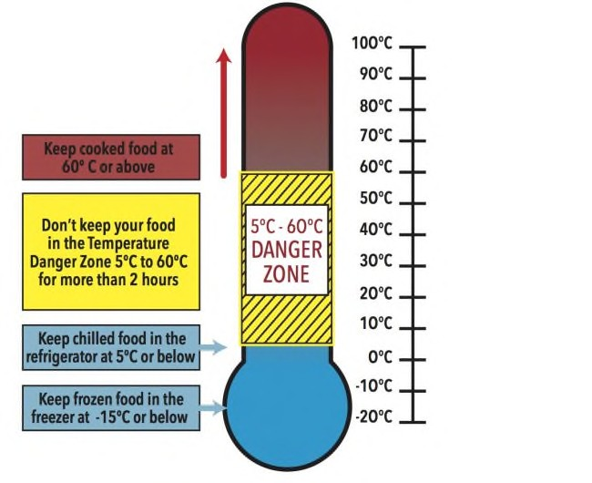
Store Food at correct temperature - Food that is meant to be kept chilled should be!
As soon as possible after purchase meat, poultry, dairy foods, vegetables, salad ingredients, etc should be refrigerated at or below 5ºC. Sounds easy but often food is left in hot cars or put in refrigerators that are not cold enough. A fridge thermometer should be used to make sure the temperature is at or below 5ºC. The temperature should be adjusted in line with changing seasons and the amount stored. Refrigerate leftovers promptly. Cooked food should be stored in covered containers and either put in the fridge to cool, or frozen immediately.
Frozen foods should be defrosted in the fridge NOT on the kitchen bench. If in doubt, throw it out!

Cook Food Properly - Properly cooking food minimises the risk of food poisoning
Cook chicken, minced or boned meats, hamburger, stuffed
meats and sausages right through until they reach 75°C using a meat thermometer. Serve hot food steaming hot above 60ºC. Defrost frozen poultry and rolled and stuffed meats thoroughly before cooking. Always follow cooking instructions on packaged foods.

Don’t Cross Contaminate foods - Cross-contamination is a major way for food borne diseases to spread
To avoid cross contamination keep raw and cooked foods separate when storing and preparing. Food should be stored in covered containers in the fridge and put raw meats and poultry in the bottom of the fridge so the juices don’t contaminate food on lower shelves. Don’t put cooked meat back on the plate the raw meat was on.

FUND RAISING ACTIVITIES:
If your church is selling food to raise funds, then you fall into the Food Standards policing area and need to conform to the following. A decision tree is shown below to help your church conform to these requirements. The numbers listed in the diagram refer to the list of issues below that you need to take into account.

Notification
It is important that all businesses that make or sell food are known to enforcement agencies so that these agencies can ensure that food businesses are handling food safely. The food safety standards require all food businesses to provide the following information to the appropriate enforcement agency before any food handling begins:
    - contact details for the business, including the name of the business and the name and address of the proprietor;
    - the nature of the business; and
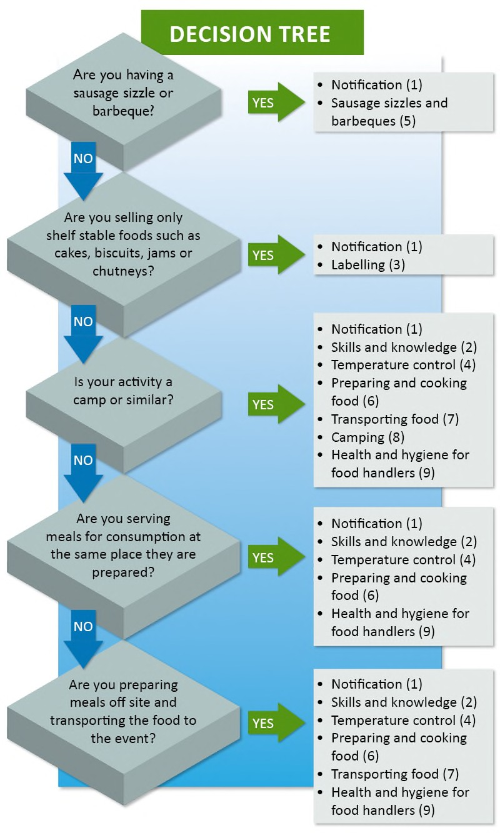
    - the location of all food premises that are within the jurisdiction of the enforcement agency.
Any changes must also be notified to the enforcement agency.
What is a food business?
The definition of a food business includes any activity where food is sold and specifically includes activities undertaken by charities and community organisations.
What is the enforcement agency?
If your business is located in a state, that is, New South Wales, Queensland, Victoria, Tasmania, South Australia or Western Australia, the enforcement agency is likely to be your local council. If your business is located in the Northern Territory or the Australian Capital Territory, the enforcement agency will be your local health department.
How to notify:
Contact your local council or health department for information on how to notify. It may be easier for your charity or community organisation to nominate one person to deal with notification requirements. This person can then discuss the requirements with the local council or health department. Simplified notification arrangements may be in place for businesses operated by charities and community organisations in your state or territory.

Skills and Knowledge
The food safety standards require proprietors of food businesses to ensure that food handlers and supervisors of food handlers have the skills and knowledge they need to handle food safely. This means that food handlers and supervisors must have the ' skills' to do those tasks that are necessary to ensure the safety of the food being handled and 'knowledge' of food safety and hygiene matters. For example, a food handler who is responsible for cooling cooked food must have the knowledge that the food must be cooled within a certain time to ensure it remains safe
and the skills to do this (for example, by placing the food in shallow containers for cooling). However, charities and community organisations are exempt from this requirement if:
- there is no personal financial gain, that is, all the moneys raised are used for charitable or community purposes; and
- the food sold is shelf-stable (for example, biscuits, cakes without cream, jams or chutneys); or
- the food is consumed immediately after thorough cooking (for example, sausages sold straight from the barbecue). This means that in the above circumstances the event organiser does not need to ensure that each food handler has the skills and knowledge to handle food safely. However, these food handlers must still comply with the health and hygiene requirements of the Food Safety Standards. If the exemption does not apply, the event organiser should ensure that all food handlers and supervisors have the skills and knowledge they need to handle food safely. The exemption does not apply if the activity involves:
- selling potentially hazardous foods that have not been cooked, such as salads or cream cakes; or
- selling potentially hazardous foods that are not served immediately after cooking, such as when food is pre-cooked and then heated for sale.

How to ensure your food handlers and supervisors have the appropriate skills and knowledge
The event organiser should first determine if the food handlers and supervisors already have the skills and knowledge, as some may have previously received food safety training. If training is needed, the event organiser will need to work out the best way of providing this training.
Food handlers and supervisors are not required to attend formal training courses. Food handlers and supervisors can obtain the skills and knowledge they need by:
- attending ' in-house' training programs
- reading food safety and hygiene information (such as these fact sheets)
- following food safety procedures that relate to the activities of the charitable or community organisation; or
- attending food safety courses.
The event organiser can check whether food handlers and supervisors have the required knowledge and understand their obligations by talking to them or asking questions. Assessing skills is much harder but if, for example, food handlers are seen to do the right thing at all times when preparing food, it is reasonable to assume that they have the necessary skills. Event organisers should consider whether:
- all food handlers know how the business expects food to be handled
- food handlers understand their health and hygiene responsibilities (see Fact Sheet 9 Health and hygiene for food handlers)
- there is someone in the organisation who is responsible for ensuring that food handlers handle food safely
- the necessary equipment is available so that food handlers can handle food safely, for example handwashing facilities.

Labelling - How to label and provide information about food sold at fundraising events
Food sold at fundraising events is exempt from most labelling requirements. However, despite these general exemptions, certain information must always be provided when relevant. Other information must be provided if the customer requests it. Refer to Standard 1.2.1 – Application of Labelling and Other Information Requirements of the Australia New Zealand Food Standards Code.

Information that must be always provided
If the food you are selling conforms to the list below then you’ll need to conform to the Standard labelling requirements. This includes:
- Directions for use and/or storage of the food, if required for health or safety reasons - Refer to Standard 1.2.6 – Directions for Use and Storage
- Country of origin information - Refer to Standard 1.2.11 – Country of Origin Requirements. Country of origin information is required on some unpackaged foods sold at fund raising events in Australia, for example, pork, fish, fruit, and vegetables. This information can be provided on or in connection with the display of the food, for example, on a label on the food or on a sign with the food.
- Genetically modified foods - Refer to Standard 1.5.2 – Food Produced Using Gene Technology
- Irradiated foods -Refer to Standard 1.5.3 – Irradiation of Food
- Royal jelly - Refer to Standard 1.2.3 – Mandatory Warning and Advisory Statements and Declarations.
- Certain fish, meat and meat products, and offal - Refer to Standard 2.2.1 – Meat and Meat Products, and Standard
2.2.3 – Fish and Fish Products
- Kava - Refer to Standard 2.6.3 – Kava

Information that must be provided if requested by the customer
There is also some basic information that you need to either provide if asked by the customer, or display with the food:
- Name of the food - Refer to Standard 1.2.2 – Food Identification Requirements
- Declaration of allergenic substances - Refer to Standard 1.2.3 – Mandatory Warning and Advisory Statements and Declarations. A declaration of the following substances is required if present in the food (as these may cause allergic reactions in some people):
  - cereals containing gluten and their products (wheat, rye, barley, oats and spelt and their hybridised strains) (except in beer and spirits)
  - crustacea and their products
  - egg and egg products
  - fish and fish products (except for isinglass derived from swim bladders and used as clarifying agent in beer and wine)
  - milk and milk products
  - peanuts and soybeans and their products
  - tree nuts and sesame seeds and their products
  - added sulphites in concentrations of 10 mg/kg or more.
- Advisory statements - Refer to clause 2 of Standard 1.2.3 for further information
- Nutrition information panels - Refer to Standard 1.2.8 – Nutrition Information Requirements

Providing information voluntarily
Despite the exemption from a number of the labelling requirements, you may still decide to voluntarily label your food for fund raising events. In addition to the information that must be provided (as outlined above), you may also choose to provide additional information that would be useful to your customers, such as a list of ingredients, a contact name and address and a best-before date.

Temperature Control of Food
The food safety standards specify that potentially hazardous foods must be stored, displayed and transported at safe temperatures and, where possible, prepared at safe temperatures. However, you can also use time, rather than temperature, to keep food safe. This method is explained under 'The 2 hour/4 hour guide'. Safe temperatures are 5°C or colder, or 60°C or hotter. Potentially hazardous food needs to be kept at these temperatures to prevent food-poisoning bacteria, which may be present in the food, from multiplying to dangerous levels. These bacteria can grow at temperatures between 5°C and 60°C, which is known as the temperature danger zone. The fastest rate of growth is at around 37°C, the temperature of the human body.
The food safety standards also require you to have a thermometer if you prepare, handle or sell potentially hazardous food. This will enable you to check that safe temperatures are being maintained.

What foods are potentially hazardous?
Foods normally considered to be potentially hazardous are:
- raw meats, cooked meats and food containing meat, such as casseroles, curries, lasagne and meat pies
- dairy products and foods containing dairy products, such as milk, cream, custard and dairy-based desserts
- seafood (excluding live seafood) and food containing seafood, such as seafood salad
- processed fruits and vegetables, such as prepared salads and ready-to-eat fruit packs
- cooked rice and pasta
- processed foods containing eggs, beans, nuts or other protein-rich food, such as quiche and soya bean products
- foods that contain any of the above foods, such as sandwiches, rice salads and pasta salads.

Cooling foods
If potentially hazardous foods have to be cooled, their temperature should be reduced as quickly as possible. The temperature should fall from 60°C to 21°C in less than two hours and be reduced to 5°C or colder in the next four hours. It is difficult to cool food within these times unless you put food into shallow containers.

Keeping food hot
If you are keeping food hot on cooktops, in ovens or in bain marie units, the equipment needs to be set high enough to ensure that the food remains hot (60 ° C or hotter).

The 2 hour / 4 hour guide
Although potentially hazardous food should be kept at 5°C or colder or 60°C or hotter wherever possible, this food can be safely between 5°C and 60°C provided it is between these temperatures for less than four hours. This is because it takes more than four hours for food-poisoning bacteria to grow to dangerous levels. The 2 hour/4 hour guide applies to ready- to-eat potentially hazardous food. It provides guidance on how long this type of food can be held safely at temperatures between 5°C and 60°C and what should happen to it after certain times. The times refer to the life of the food, including preparation and cooling, not just to display times, so remember to add up the total time that the food has been between 5°C and 60°C.
Total time limit between 5°C and 60°C | What you should do
Less than 2 hours | Refrigerate or use immediately
Between 2 hours and 4 hours | Use immediately
More than 4 hours | Throw out

Sausage Sizzles and BBQs
Sausage sizzles and barbecues are a popular way to raise money for charities and community organisations. They are often held outdoors to take advantage of Australia's good weather and open spaces. Provided you take some simple food safety precautions and sell freshly cooked food straight from the barbecue, the food should be safe.

Preparing and cooking food safely
Take the following precautions at sausage sizzles and barbecues to ensure that food is safe.
- Finish preparing raw meat before leaving for the site such as slicing, marinating or skewering.
- Pack raw meat into insulated boxes with ice bricks for transportation.
- Handle food with tongs or other equipment. Use separate equipment to handle raw and cooked meats. Hands should not be used unless absolutely necessary, and then handwashing facilities must be available. Hands must be washed after handling raw meats.
- Keep cooked meat and salads separate from raw meat at all times to prevent contamination.
- Cover food to protect it from contamination.
- Use clean and dry utensils for serving the food -never place cooked meat back on the trays that held the raw meat.
- Cook chicken, sausages and hamburgers until juices run clear - steaks can be cooked to preference.
- Throw left-over food away unless refrigeration equipment is available to rapidly cool the food.

Disposable utensils
Wherever possible, single-use (disposable) utensils such as knives, forks, plates and cups should be used and thrown away after use. These items should be kept covered until required and should be handled carefully to minimise any risk of contamination. Re-useable items such as mugs should not be used unless there are facilities available on-site to wash and sanitise them, or there are enough items for the duration of the event.

Water
If water is needed for hand washing or for washing up, a supply adequate to last the event must be provided. The water must be of drinkable quality. If using containers to transport water to the event, make sure that they are clean and have not been used to store chemicals. If you do not have access to hot water for washing up, make sure that you take enough utensils so that you can use separate utensils for the raw and the cooked food at the event.

Handwashing facilities
Unless a written exemption has been obtained from your local council or health authority, food handlers must wash their hands with warm running water. An exemption is only likely to be issued where enough water is not available for handwashing. In such circumstances the local council or health authority may permit the use of alternatives such as cleaning creams or gels, or sanitising wipes. If you have access to water, you should set up a temporary handwashing facility that provides running water. You can do this by using a large water container with a tap at its base. Another container, such as a bucket, should collect the waste water, to keep the site dry and clean. A supply of soap and paper towels must be provided at the handwashing facility so that handwashing can be undertaken properly. Supply a bin for used towels. This helps to keep the site tidy and prevents contamination from used towels.

Preparing and Cooking Food Buying food
When you buy potentially hazardous food, place it in insulated bags or boxes for transporting to the preparation place if it is not close to your shops. Place your potentially hazardous food in a refrigerator or freezer as soon as possible.
Temperature control for a list of foods that are potentially hazardous.

Preparing food
Before preparing food, make sure that hands, clothes, equipment and kitchen surfaces are clean. They will also need to be kept clean throughout food preparation. If your event is to be held outdoors with limited facilities, prepare the food in a kitchen and then transport it to the event. This does not mean that you need to cook food before you take it to the event but, for example, you should slice the raw meat ready for cooking. In fact, food that is freshly cooked at the event and served straight away, such as occurs with barbecues, has less chance of becoming unsafe than food that is pre- cooked and then taken to the event. Therefore, wherever possible, try to cook food at the event rather than pre-cooking it.

Preventing food from becoming contaminated during preparation
The most important step to remember before preparing food is to wash and dry your hands thoroughly. Try to use tongs and other utensils when preparing food that will not be cooked before it is eaten, such as salads and sandwiches. You may prefer to wear gloves, but remember that they should be used for one task only (for example, breaking up a cooked chicken for sandwiches). When you start the next task, wear new gloves. Never use the same utensils for raw meats and foods that are ready to eat, such as cooked meats, unless they have been thoroughly cleaned, sanitised and dried. Cooked food and other food that is ready to eat, such as salads, should always be placed on clean and dry serving dishes.

Cleaning and sanitising utensils
There are three steps needed to effectively clean and sanitise utensils:
- washing;
- sanitising; and
- drying.
Utensils such as cutting boards, bowls and knives need to be thoroughly washed in warm soapy water. After washing, the utensils should look clean and there should be no food or anything else visible on them. Effective cleaning will remove most of the dangerous bacteria present. Sanitising will then kill any that might remain. A dishwasher is very effective at sanitising if it has a hot wash and drying cycle. If you do not have a dishwasher, you will need to sanitise in a sink using a chemical sanitiser or very hot water. If using a chemical sanitiser such as a sodium hypochlorite - or quaternary ammonium - based solution, ensure that it can be safely used for sanitising eating, drinking and cooking utensils. Follow the instructions on the container carefully, as different sanitisers work in different ways. If you are using very hot water, take extra care to avoid being scalded. All utensils must then be thoroughly dried before they are re-used. Air-drying is best but tea towels can be used if they are clean. If you are washing up at an event being held outdoors, make sure you have access to plenty of hot water. If hot water is not available, disposable eating and drinking utensils should be used and enough cooking utensils provided to last the duration of the event so that washing up is not necessary.

Cooking
Always cook food thoroughly. Do not partially cook food and then warm it up later. Cook chicken, sausages and hamburgers until juices run clear - beef steaks can be cooked to preference. Cooking will reduce dangerous bacteria to safe levels if it is done properly. Remember that some food-poisoning bacteria can protect themselves from cooking and while they will not be present in enough numbers to make someone sick just after the food is cooked, they can start growing again if the cooked food is left at temperatures between 5°C and 60°C for too long. This is why cooling cooked food quickly is so important. Wherever possible, try to cook food as close to the time that you will be serving or selling it. For example, if you can, take the food to the event and cook it there. This reduces the chance of the food becoming contaminated after it has been cooked. It also means that there won' t be enough time for food-poisoning bacteria to grow to dangerous levels on the cooked food before it is eaten. If it isn' t practical to cook food at the event, you will need to pre-cook the food and transport it hot, or alternatively cook it, cool it and then transport it cold.

Cooling food
If you decide you want to pre-cook food and then cool it, you will need to ensure that the food is cooled rapidly to 5°C. If a large container of cooked food, for example a beef curry, is placed in a refrigerator for cooling, it can take as long as 24 hours to cool to 5°C. This is very dangerous as the centre of the food will remain warm and allow food-poisoning bacteria to grow to dangerous levels. The Food Safety Standards require cooked food to be cooled to 5°C within 6 hours. The food must be cooled from 60°C to 21°C within 2 hours and from 21°C to 5°C within a further 4 hours. Safe cooling can be achieved by:
- removing the food from the stove top, oven or other heat source after it has cooked;
- allowing the food to initially cool outside the refrigerator - but make sure it is placed in the refrigerator as soon as any part of it drops to a temperature of 60°C; and
- placing the food in shallow containers.
You will need to use your thermometer to check that the cooked food is being cooled within the 6-hour time limit.

Reheating food
Cold food (which is to be served hot) will need to be quickly and thoroughly heated at the event until it is steaming hot and then kept hot until it is served. It is best to re-heat the food to a temperature of 70°C and hold the food at this temperature for at least two minutes. Use your thermometer to check that all of the food reaches at least this temperature.

Keeping food hot
Hot food will need to be kept hot (60 ° C or above) at the event. This could be achieved by using gas or electric appliances.

Making sandwiches
Sandwiches are a popular product for community and fundraising events. Making them usually involves a lot of handling, which makes personal hygiene very important. Sandwiches are often filled with potentially hazardous food and should be handled and stored like any other high-risk food. They should be made fresh as close to the start of the event as possible. If this is not practical, they should kept in a refrigerator. Make sure that you have enough refrigerator space to store them safely - they may take up a lot of room. Because sandwiches require a lot of handling, the contact time with the person making them is increased. Because of this, it is very important that people who are ill do not make the sandwiches. Sandwiches should be kept under temperature control when they are transported and displayed for sale.
Alternatively, you could use time, rather than temperature, to keep the sandwiches safe.

Transporting Food
When you are transporting food, you need to consider two main food safety issues: keeping the food protected from contamination and, if the food is potentially hazardous, keeping it cold (5°C or colder) or hot (60°C or hotter).

Protecting food from contamination
It is important to protect food from contamination by keeping it covered at all times. You can achieve this by using containers with lids or by applying plastic film over containers. Materials used to cover food should be suitable for food contact, to ensure that they do not contain any chemicals that could leach into the food. Aluminium foil, plastic film and clean paper may be used, and food should be completely covered. Packaged products should not need additional covering. Previously used materials and newspaper may contaminate food and should not be used.

Temperature control
When potentially hazardous foods are transported they should be kept cold (5°C or colder) or hot (60°C or hotter) during the journey. Alternatively, you could use time, rather than temperature, to keep the food safe while it is being transported. If the journey is short, insulated containers may keep the food cold. If the journey is longer, you may need to use ice bricks to keep food cold and heat packs to keep food hot. Place only pre-heated or pre-cooled food in an insulated container, which should have a lid to help maintain safe temperatures. Insulated containers must be:
- in good condition and kept clean at all times
- used only for food
- kept away from other items such as chemicals, pet food, fuel and paint
- be filled as quickly as possible and closed as soon as they have been filled.
- kept closed until immediately before the food is needed or is placed in other temperature-controlled equipment.

Transport considerations
- Containers of cool food should be placed in the coolest part of the vehicle.
- If the inside of the vehicle is air-conditioned, cold food may be transported better here rather than in the boot.
- Vehicles should be clean. If the vehicle is normally used for carrying pets or dirty equipment, the food carrying area should be thoroughly cleaned or lined to prevent any contamination. This may not be necessary if food is transported in an insulated container with a tightly fitting lid.
- The journey should be properly planned and should be kept as short as possible.
- When collecting ingredients, cold foods should be collected last and immediately placed in insulated containers or cool bags for transporting to the preparation facility.
- When taking prepared foods to a venue, pack the food into insulated boxes as your last job.
- When you arrive at the venue, make it your first job to unload any hot or cold food and place it in temperature- controlled equipment.

Camping
Preparing food for camps can be very challenging because facilities found in the home or commercial food premises are not generally available. You need to properly plan to ensure food safety. The camp should be memorable only for the outdoor experience and not the food poisoning outbreak that could occur. The five main considerations for keeping food safe in camps are:
- temperature control of food
- water supply
- handwashing facilities
- protecting food from contamination
- disposal of rubbish and waste water to prevent the contamination of food.

Temperature control
The use of potentially hazardous foods when camping should be kept to a minimum unless the food can be kept cold (5°C or colder). Potentially hazardous foods support the growth of bacteria that can cause illness if large numbers of bacteria are present. If your camp is catering for a large number of people, it may be practical to hire gas-powered refrigeration equipment or to use similar facilities close to the campsite. If you only have limited equipment to keep food cold, buy potentially hazardous foods fresh daily and throw away any leftover food. You could also consider purchasing foods that are shelf-stable. These are foods that do not need temperature-controlled storage until they are opened. Examples include long-life milk (heat-treated in the carton); canned meats, fish and dairy products; and dried and dehydrated foods.

Water supply
A safe water supply is probably the most important requirement when camping because water is necessary for preparing and cooking food, cleaning utensils and helping to maintain personal hygiene. Your camp will need access to water of drinking quality. If water at the site is not suitable for drinking, it will need to be treated. The easiest way to treat this water is to boil it, but it has to be protected from contamination during cooling and storage. It is not always practical to boil the amount of water needed for food preparation and personal hygiene and you may wish to use chemical sterilisation. Always follow the manufacturers' instructions when using these chemicals. Water filters may also be an option but they can be slow and must be maintained in good working condition. You will also need to check with the supplier of the filter to find out whether it will be effective for your purposes. Filters should not be damaged and they may need to be cleaned or replaced regularly. Sources of drinking water, such as streams, wells and bores, should be protected. Access to the water collection point should be restricted and the area protected from animals and foreign matter. Use only clean containers that are specifically kept for drinking water. Store them carefully at all times, whether they are full or empty, with their lids fastened.

Handwashing
For effective handwashing, clean warm running water is needed so that soap can function correctly and hands can be rinsed before they are dried. During camping, clean running water is not always readily available. A suitable alternative must be provided to ensure that hands do not contaminate food. You will need to obtain approval to use alternative handwashing methods from your local council or health authority. Alternative methods include the use of sterile wipes or cleaning gels. If you have access to water of drinking quality, you should set up a temporary handwashing facility that provides running water. You can do this by using a large water container with a tap at its base. Another container, such as a bucket, should collect the waste water, to keep the site dry and clean. A supply of soap and paper towels must be provided at the handwashing facilities so that handwashing can be undertaken properly. Supply a bin for used towels.
This helps to keep the site tidy and prevents contamination from used towels.

Protecting food from contamination
It is very important to protect food from contamination. Bacteria cannot move from place to place by themselves they need help from poor food-handling practices. Poor food handling often allows bacteria to be transferred from a non-food source to food, and from one food to another. The risk of contamination is often greater when camping because only basic equipment and amenities may be available. To protect food from contamination:
- wash your hands before preparing or handling food;
- keep food covered;
- use separate utensils such as knives and chopping boards for different foods;
- keep raw meat and raw fruits and vegetables well away from foods which are ready to eat, such as cooked meat and salads;
- always thoroughly wash and dry your hands after handling raw meat; and
- thoroughly wash and dry eating and drinking utensils and store in a clean place.

Disposal of rubbish and waste water
The disposal of rubbish and waste water needs careful planning because they attract pests and contaminate food if they are not properly stored and disposed of. Rubbish should be bagged and tied, and kept well away from food preparation areas. There may be a designated disposal area for waste water at your camping site. Always use this - do not dispose of waste water in or near water sources.

Health and hygiene for food handlers
The food safety standards contain requirements that apply only to food handlers. These requirements relate to health and hygiene and have been included to ensure that food handlers take steps to avoid contaminating food. A food handler is anyone who handles food or items that may come into contact with food, such as eating and drinking utensils. All food handlers are legally obliged to comply with the health and hygiene requirements set out in the food safety standards.
Food businesses must inform all food handlers of their health and hygiene obligations under the food safety standards. To help food businesses comply with the requirement, a copy of the health and hygiene requirements has been included as part of this fact sheet. You could ask all food handlers to sign a form, to say that they have received this fact sheet and
the attached requirements. This is a good way of keeping checks on who has been advised. It also provides evidence that this requirement has been fulfilled. You may want to delegate this responsibility to one person in your organisation so that a consistent approach is taken and no volunteers are missed.

Health requirements
If you are ill or have an infection you can easily transfer harmful bacteria or viruses to food. Do not handle food if:
- you are ill with vomiting, diarrhea, fever or sore throat with fever; or
- your doctor has diagnosed that you have or carry a foodborne illness.
If you have volunteered for an event and then become ill with any of the above symptoms, let the event organiser know that you can no longer work. This is very important, no matter how short-staffed the event may be. Food handlers who are ill can easily make food unsafe. Not only is it against the law, it is not worth the risk. If you start to feel unwell while you are at an event, stop handling food and let the event organiser know immediately. If you have:
- infected sores on your hands, arm or face; or
- any discharges from your ear, nose or eyes (such as a cold)
you can continue to handle food provided you take extra precautions to prevent food being contaminated. For example, cover the skin sore or take medication to dry up the discharge.

Hygiene requirements General hygiene
Each food handler must take all precautions to ensure that food or surfaces that come in contact with food are not contaminated by his or her body or anything he or she is wearing. This includes hair, saliva, mucus, sweat, blood, fingernails, clothes, jewellery or bandages. You are required to:
- avoid handling ready-to-eat food such as salads and cooked food use tongs or other implements instead;
- wear clean outer clothing;
- make sure bandages and dressings on exposed parts of your body (such as the hands, arms or face) are covered with waterproof coverings;
- not eat over uncovered food or equipment and utensils;
- not sneeze, blow or cough over uncovered food or equipment and utensils; and
- not spit, smoke or chew tobacco where food is handled.

Handwashing
The most important measure to protect food from contamination is proper handwashing because clean and dry hands limit the transfer of harmful organisms to food. The Food Safety Standards require food handlers to wash their hands whenever hands are likely to be a source of contamination of food, including:
- before handling food;
- between handling raw food and food that is ready to eat, such as cooked food and salads;
- after using the toilet;
- after smoking, coughing, sneezing, blowing the nose, eating or drinking;
- after touching hair, scalp, mouth, nose or ear canal; and
- after handling rubbish and other waste.

There are five steps that should be followed when washing hands. These are:
- wet hands under warm running water;
- soap hands, lathering well;
- rub thoroughly, including the wrists and between the fingers;
- rinse in clean water; and
- dry thoroughly on paper towel, leaving no moisture on the hands.

Below is an extract from the Safe Food Australia Policy Division 4 - Health and hygiene requirements Subdivision 1 - Requirements for food handlers

General requirement
A food handler must take all reasonable measures not to handle food or surfaces likely to come into contact with food in a way that is likely to compromise the safety and suitability of food.

Health of food handlers
- A food handler who has a symptom that indicates the handler may be suffering from a food-borne disease, or knows he or she is suffering from a food-borne disease, or is a carrier of a food-borne disease, must, if at work:
  - report that he or she is or may be suffering from the disease, or knows that he or she is carrying the disease, to his or her supervisor, as the case may be;
  - not engage in any handling of food where there is a reasonable likelihood of food contamination as a result of the disease; and
  - if continuing to engage in other work on the food premises - take all practicable measures to prevent food from being contaminated as a result of the disease.
- A food handler who suffers from a condition must, if at work:
  - if there is a reasonable likelihood of food contamination as a result of suffering the condition - report that he or she is suffering from the condition to his or her supervisor; and
  - if continuing to engage in the handling of food or other work - take all practicable measures to prevent food being contaminated as a result of the condition.
- A food handler must notify his or her supervisor if the food handler knows or suspects that he or she may have contaminated food whilst handling food.

Hygiene of food handlers
  - A food handler must, when engaging in any food handling operation:
    - take all practicable measures to ensure his or her body, anything from his or her body, and anything he or she is wearing does not contaminate food or surfaces likely to come into contact with food;
    - take all practicable measures to prevent unnecessary contact with ready-to-eat food;
    - ensure outer clothing is of a level of cleanliness that is appropriate for the handling of food that is being conducted.
    - only use on exposed parts of his or her body bandages and dressings that are completely covered with a waterproofed covering;
    - not eat over unprotected food or surfaces likely to come into contact with food;
    - not sneeze, blow or cough over unprotected food or surfaces likely to come into contact with food;
    - not spit, smoke or use tobacco or similar preparations in areas in which food is handled; and
    - not urinate or defecate except in a toilet.
  - A food handler must wash his or her hands in accordance with subclause (4):
    - whenever his or her hands are likely to be a source of contamination of food;
    - immediately before working with ready-to-eat food after handling raw food; and
    - immediately after using the toilet.
  - A food handler must, when engaging in a food handling operation that involves unprotected food or surfaces likely to come into contact with food, wash his or her hands in accordance with subclause (4):
    - before commencing or re-commencing handling food;
    - immediately after smoking, coughing, sneezing, using a handkerchief or disposable tissue, eating, drinking or using tobacco or similar substances; and
    - after touching his or her hair, scalp or a body opening.
  - A food handler must, whenever washing his or her hands:
    - use the hand washing facilities provided;
    - thoroughly clean his or her hands using soap or other effective means, and warm running water; and
    - thoroughly dry his or her hands on a single use towel or in another way that is not likely to transfer pathogenic micro-organisms to the hands.
  - A food handler who handles food at temporary food premises does not have to clean his or her hands with warm running water, or comply with paragraph (4)(c), if the appropriate enforcement agency has provided the food business operating from the temporary food premises with approval in writing for this purpose.

SELLING FOOD AS A BUSINESS
If your church runs a café or sells food as a business in the community, then you need to check and ensure you are registered with the local authority and conform to the current legislation for food handling and associated requirements. You’ll need to seek your own advice to ensure compliance.

Consult your workers

APPENDIX B - How to identify hazardous manual tasks

Workers who perform manual tasks can provide valuable information about discomfort, muscular aches and pains that can signal potential hazards. For example, you could ask workers to identify tasks that:
  - are difficult to do (or appear harder than they should be)
  - are very tiring (muscle fatigue reduces work capacity)
  - are awkward or dangerous (for example, difficulty controlling loads)
  - cause discomfort.

Review available information
Records of workplace injuries and incidents, inspection reports and any workers compensation claims made for MSDs should be reviewed to help identify which manual tasks may cause harm. However, not all hazardous manual tasks will be associated with reported incidents, therefore it is important to gather additional information. Information and advice about hazardous manual tasks and risks relevant to particular industries and work activities is available from regulators, industry associations, unions, technical specialists and safety consultants.

Look for trends
You may be able to identify trends or common problems from the information you collect. Trends may show that certain tasks have more characteristics that make them hazardous or that some characteristics are more common in certain jobs. Trends may also show that workers in a particular location are exposed to more hazardous manual tasks than in other areas and this could indicate a problem with the design and layout of that work area or the way work is carried out there. These trends may help in deciding which manual tasks should be addressed as a priority.

Observe manual tasks
Hazardous manual tasks can also be identified by looking at how people actually work and focussing on their postures and movements. A manual task is hazardous if it involves any of the following characteristics (see table below):
  - repetitive or sustained force
  - high or sudden force
  - repetitive movement
  - sustained and/or awkward posture
  - exposure to vibration.

Things to look out for include:
  - any changes that have resulted in new manual tasks or a changed environment
  - tasks involving tools, machinery or equipment that do not work properly or are difficult to use, and
  - if workers have made improvisations to tasks to avoid discomfort (such as stacking mats or flattened cartons to stand on).

The hazard identification worksheet (Form 02) may be used to record your findings.

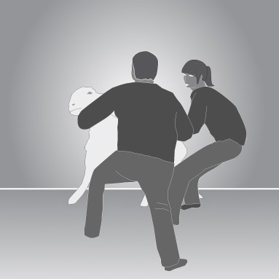
Characteristics of Hazardous Manual Tasks
Force is the amount of muscular effort required to perform a movement or task. Forceful muscular exertions overload muscles, tendons, joints and discs and are associated with most MSDs.
Repetitive force - using force repeatedly over a period of time to move or support an object | Examples of repetitive force include:  - lifting and stacking goods onto a pallet  - gripping and handling bricks when bricklaying (Figure 1)  - repetitively pressing components with the thumbs or other part of the hand to assemble an item  - prolonged application of therapeutic massage treatments  - removing splinting material from patients using shears. | Figure 1
Sustained force - occurs when force is applied continually over a period of time. | Examples of sustained force include:  - pushing or pulling a trolley around hospital wards (Figure 2)  - holding down a trigger to operate a power tool  - supporting a plaster sheet while fixing it to a ceiling  - carrying objects over long distances  - supporting, positioning or stabilising a patient’s limb during surgery or when applying splinting or casting material | Figure 2
High force – may be exerted by the back, arm or leg muscles or by the hands and fingers.  High force occurs in any tasks that:  a worker describes as very demanding physically  a worker needs help to do because of the effort it requires  require a stronger person or two persons to do the task. | Examples of high force include:  - Lifting, lowering or carrying a heavy object  - Lifting, lowering or carrying an object that cannot be positioned close to the body  - pushing or pulling an object that is hard to move or stop  - restraining a person or animal. (Figure 3) | Figure 3
 | Examples of high force using the hands and fingers include:  - using a finger-grip, a pinch-grip or an open- handed grip to handle a heavy or large load  - operating hand tools with tight squeeze grips (Figure 4)  - gripping small instruments with high force, for example, a dental hygienist cleaning teeth. | Figure 4

Force is the amount of muscular effort required to perform a movement or task. Forceful muscular exertions overload
muscles, tendons, joints and discs and are associated with most MSDs.
Sudden force – jerky or unexpected movements while handling an item or load are particularly hazardous because the body must suddenly adapt to the changing force.  Tasks where force is applied suddenly and with speed also generates high force. | Examples of sudden force include:  - impact recoil of a large nail gun  - throwing or catching objects  - cutting reinforcement steel with large bolt cutters  - carrying an unbalanced or unstable load such as bagged stock feed pellets that suddenly moves (Figure 5)  - handling frightened or resistant animals  - handling patients who suddenly resist or no longer assist during the handling procedure. | Figure 5
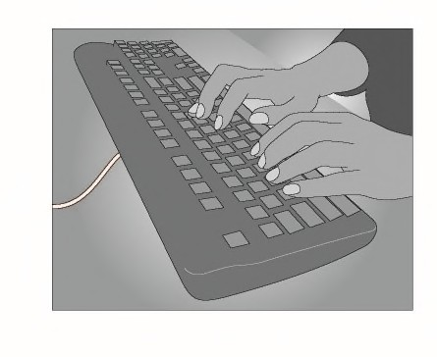
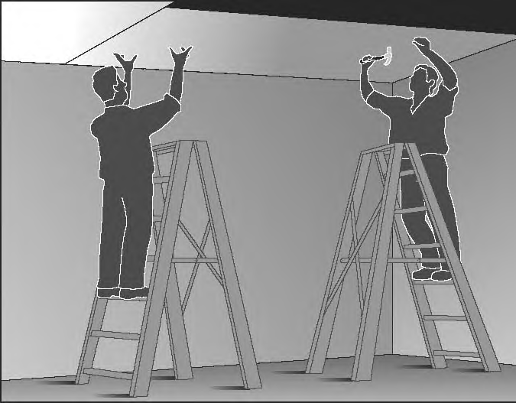
Movement
Repetitive movement – using the same parts of the body to repeat similar movements over a period of time. | Examples of repetitive movement include:  - painting  - lifting goods from a conveyor belt and packing them in a carton  - typing and other keyboard tasks(Figure 6)  - repeatedly reaching for and assembling components in electronics manufacturing  - using a socket and ratchet or spanner to unscrew long bolts. | Figure 6

Posture
An ideal posture is one where the trunk and head are upright and forward facing, the arms are by the side of the body, the forearms are either hanging straight or at right angles to the upper arm, and the hand is in the handshake position.
Postures that are both awkward and sustained are particularly hazardous.
Sustained posture – where part of or the whole body is kept in the same position for a prolonged period. | Examples of sustained posture include:  - supporting plasterboard sheeting while it is nailed into place (Figure 7)  - continually standing with weight mainly on one leg while operating a power press with foot pedal controls. | Figure 7

Awkward posture –  where any part of the body is in an uncomfortable or unnatural position, such as:  - postures that are unbalanced or asymmetrical  - postures that require extreme joint angles or bending and twisting. | Examples of awkward posture include:  - squatting while servicing plant or a vehicle  - working with arms overhead  - bending over a desk or table  - using a hand tool that causes the wrist to be bent to the side  - kneeling while trowelling concrete or laying carpet  - bending the neck or back to the side to see around bulky items pushed on a trolley.  (Figure 8) | Figure 8  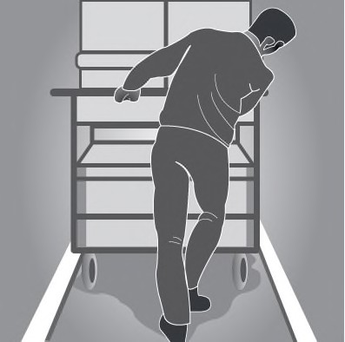
Vibration There are two common forms of vibration according to contact points between the body and the source:
Whole body vibration occurs when vibration is transmitted through the whole body, usually via a supporting surface, such as a seat or the floor in heavy vehicles or machinery. This may result in lower back pain, degeneration of the lumbar vertebrae and disc herniation. | Examples of whole body vibration include:  - operating mobile plant such as heavy earth moving machinery  - driving a vehicle over rough terrain. (Figure 9) | Figure 9
Hand-arm vibration occurs when vibration is transferred through a vibrating tool, steering wheel or controls in heavy machinery to the hand and arm. This can disrupt blood circulation in the hand and forearm and damage nerves and tendons. Localised vibration contributes to ‘vibration-induced white finger’ and ‘carpal tunnel syndrome’ through the gripping force needed to hold the vibrating tools (the tighter the grip, the more vibration is absorbed) and the repetitive shock loads of some tools. | Examples of hand-arm vibration include:  - using impact wrenches, chainsaws, jackhammers, grinders, drills or vibrating compacting plates (Figure10-11)  - using needle guns in de-rusting metal. | Figure 10-11
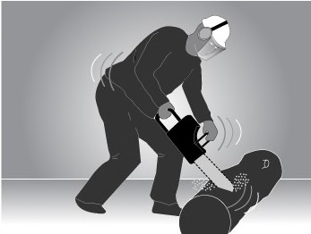
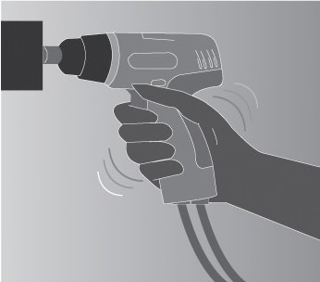
Further information can be found on the Safe Work Australia website https://www.safeworkaustralia.gov.au – search “Hazardous Manual Tasks”

APPENDIX C - Safe use of ladders
Ladders are primarily a means of access and egress. Many falls take place when people are working from ladders. In addition, when using a ladder:
  - the working width and movement is limited
  - the time involved in moving and setting up ladders is often underestimated when planning work
  - the working position on ladders is often uncomfortable (the need to stretch sideways, work above shoulder height and stand on narrow rungs for a long time) and may cause musculoskeletal disorders.
For these reasons, you should consider whether an elevating work platform or scaffolding would be safer and more efficient.

Portable ladders
Extension or single ladders should generally only be used as a means of access to or egress from a work area. They should only be used as a working platform for light work of short duration that can be carried out safely on the ladder.

Selecting ladders
If ladders are used they must be selected to suit the task to be undertaken. In doing this, you should consider the duration of the task, the physical surroundings of where the task is to be undertaken and the prevailing weather conditions. Ladders should have a load rating of at least 120 kg and be manufactured for industrial use.

Positioning ladders
Any ladder used at a workplace must be set up on a solid and stable surface, and set up so as to prevent the ladder from slipping. Single and extension ladders can be prevented from slipping by:
  - placing ladders at a slope of 4:1, and setting up stepladders in the fully opened position
  - securing ladders at the top or bottom, or if necessary, at both ends (see Figure 27).

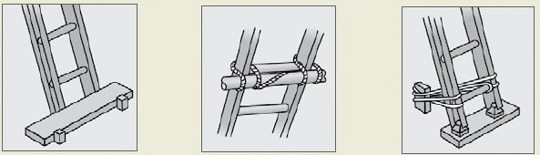
Figure: Some effective ways of securing a ladder

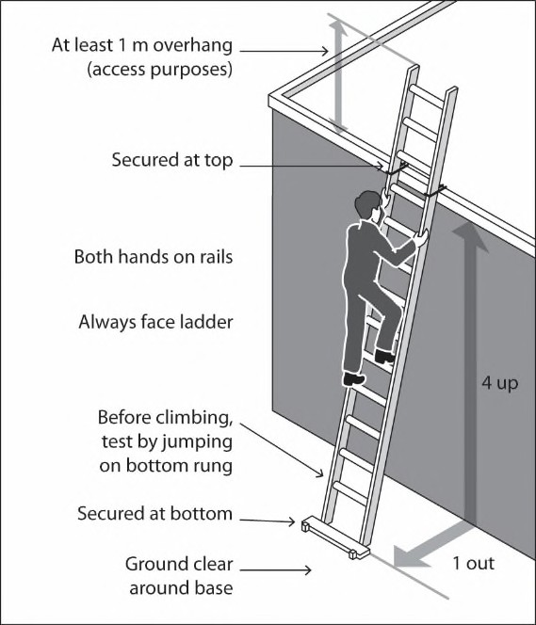
Access or egress
Where fixed or extension ladders are used for access or egress, you should check that:
  - there is a firm, stable work platform, free from obstructions, to step onto from the ladder
  - the ladder extends at least one metre above the stepping-off point on the working platform
  - fall protection is provided at the stepping-off point where people access the working platform.

Figure: Example of acceptable ladder use

Safe Use of Ladders
When a ladder is used, you should check that:
  - the ladder is in good condition—the ladder should be inspected for faults, such as broken rungs, stiles and footing before it is used
  - damaged ladders are removed from service
  - the ladder is set up on firm, stable and level ground
  - the ladder is the correct height for the task to avoid reaching or stretching
  - the ladder is not too close or too far from the support structure—the distance between the ladder base and the supporting structure should be about one metre for every four metres of working ladder height (4:1 ratio)
  - the ladder is secured against displacement (i.e. slipping or sliding) and/or there is another person holding the base of the ladder
  - the ladder is not placed so that the weight of the ladder and any person using the ladder is supported by the rungs
  - all the locking devices on the ladder are secure
  - materials or tools are not carried while climbing the ladder—use a tool belt or side pouch
  - only light duty work is undertaken while on the ladder, where three points of contact can be maintained and tools can be operated safely with one hand
  - slip resistant base, rungs or steps are provided
  - slip resistant shoes are worn
  - ladders are not used without additional appropriate precautions:
    - in access areas or doorways—if necessary, erect a barrier or lock the door shut
    - on scaffolding or an elevating work platform to get extra height
    - next to power lines unless the worker is trained and authorised and the appropriate ladder is being used
    - in very wet or windy conditions
    - next to traffic areas, unless the working area is barricaded.

Figure: A step platform can provide a stable work surface
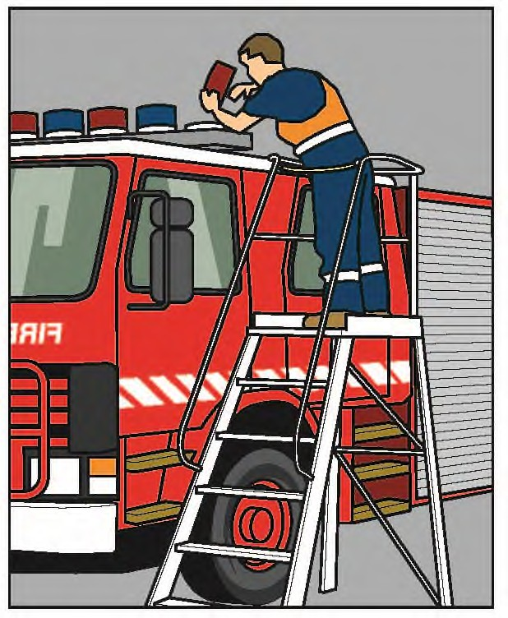

When using ladders, it is not safe to:
  - use metal or metal reinforced ladders when working on live electrical installations
  - carry out work such as arc welding or oxy cutting
  - work over other people
  - allow anyone else to be on the ladder at the same time.
Except where additional and appropriate fall protection equipment is used in conjunction with the ladder, it is not safe to:
  - use a stepladder near the edge of an open floor, penetration or beside any railing
  - over-reach (the centre of the torso should be within the ladder stiles throughout the work)
  - use any power or hand tool requiring two hands to operate, such as concrete cutting saws and circular saws
  - use tools that require a high degree of leverage force which, if released, may cause the user to over-balance or fall from the ladder, such as pinch bars
  - face away from the ladder when going up or down, or when working from it
  - stand on a rung closer than 900 mm to the top of a single or extension ladder

  - stand higher than the second tread below the top plate of any stepladder (with the exception of three-rung step ladders).

Guidance on the selection, safe use and care of portable ladders is set out in AS/NZS 1892 Portable ladders series. The manufacturer’s recommendations on safe use should also be followed.

Examples of unsafe ladder use
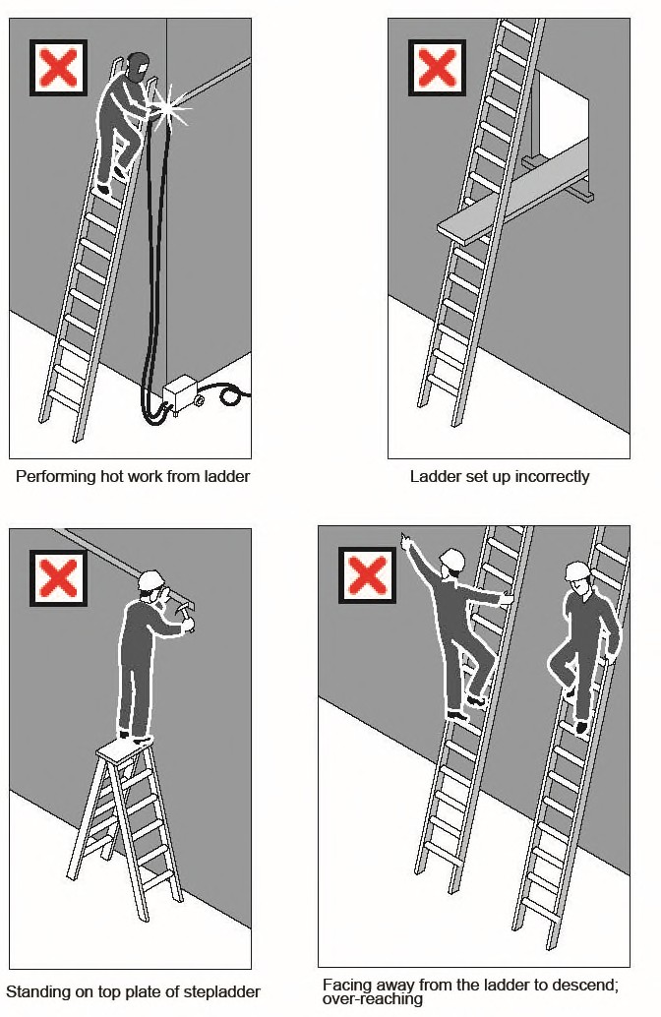

Further information can be found on the Safe Work Australia website https://www.safeworkaustralia.gov.au – search “risk of falls”

APPENDIX D - Safe Noise Levels
Sound level (dB) | Maximum exposure  time (minutes)
85 | 480 (8 hours)
88 | 240 (4 hours)
91 | 120 (2 hours)
94 | 60 (1 hour)
97 | 30
100 | 15
103 | 7.5
106 | 3.75
109 | 1.88
112 | 0.94
115 | 0.47
118 | 0.23
121 | 0.12
124 | 0.06

Sound level (dB) | Equivalent noise sources
65 | Normal conversation
80 | Hair dryer
85 | Smoke alarm / hand saw
90 | Lawn mower
95 | Loud crying / hand circular saw
100 | Jackhammer at 10m
105 | Chainsaw at 1m
110 | Siren at 10m
115 | Sandblasting / rock concert
120 | Threshold of pain

Ensure appropriate noise levels
Make sure noise levels do not go above:
  - an average exposure level of 85 decibels over an eight-hour period (the relationship between noise level and exposure time is logarithmic - for every three-decibel increase in noise, the exposure time needs to be halved in order not to exceed the exposure level)
  - peak noise levels no greater than 140 decibels at any time during the day.

Ideally, you should keep noise levels below:
  - 50 decibels if your work requires high concentration or effortless conversation
  - 70 decibels if your work is routine, fast-paced and demands attentiveness, or if it is important to carry on conversations.

Here are six easy ways to help you keep noise levels low:
  - Buy the quietest plant and machinery for the job – and always ask the manufacturer/supplier for information about noise levels.
  - Change the way you do the job – eg glue don’t hammer, weld don’t rivet, lower don’t drop.
  - Reduce noise levels at the source – eg fit silencers to exhausts, turn down the volume, change fan speeds.
  - Isolate the source of the noise – eg use barriers, remote controls or sound-proof covers.
  - Reduce exposure levels – eg restrict access to noisy areas, provide quiet areas for rest breaks, limit time spent in noisy areas.
  - Use personal hearing protection, but only as a last resort.

APPENDIX E - First Aid Kits
Example of contents for a first aid kit
For most workplaces, a first aid kit should include the following items:

Kit contents
Item | Quantity
Instructions for providing first aid – including Cardio-Pulmonary Resuscitation (CPR) flow chart | 1
Note book and pen | 1
Resuscitation face mask or face shield | 1
Disposable nitrile examination gloves | 5 pairs
Gauze pieces 7.5 x 7.5 cm, sterile (3 per pack) | 5 packs
Saline (15 ml) | 8
Wound cleaning wipe (single 1% Cetrimide BP) | 10
Adhesive dressing strips – plastic or fabric (packet of 50) | 1
Splinter probes (single use, disposable) | 10
Tweezers/forceps | 1
Antiseptic liquid/spray (50 ml) | 1
Non-adherent wound dressing/pad 5 x 5 cm (small) | 6
Non-adherent wound dressing/pad 7.5 x 10 cm (medium) | 3
Non-adherent wound dressing/pad 10 x 10 cm (large) | 1
Conforming cotton bandage, 5 cm width | 3
Conforming cotton bandage, 7.5 cm width | 3
Crepe bandage 10 cm (for serious bleeding and pressure application) | 1
Scissors | 1
Non-stretch, hypoallergenic adhesive tape – 2.5 cm wide roll | 1
Safety pins (packet of 6) | 1
BPC wound dressings No. 14, medium | 1
BPC wound dressings No. 15, large | 1
Dressing – Combine Pad 9 x 20 cm | 1
Plastic bags - clip seal | 1
Triangular bandage (calico or cotton minimum width 90 cm) | 2
Emergency rescue blanket (for shock or hypothermia) | 1
Eye pad (single use) | 4
Access to 20 minutes of clean running water or (if this is not available) hydro gel (3.5 gm sachets) | 5
Instant ice pack (e.g. for treatment of soft tissue injuries and some stings) | 1

Medication, including analgesics such as paracetamol and aspirin, should not be included in first aid kits because of their potential to cause adverse health effects in some people including asthmatics, pregnant women and people with medical conditions. The supply of these medications may also be controlled by drugs and poisons laws. Workers requiring prescribed and over-the-counter medications should carry their own medication for their personal use as necessary.
Some types of workplaces may require additional items to treat specific types of injuries or illnesses.

If work is performed outside and there is a risk of insect or plant stings or snake bites, assess whether the following items should also be included in the first aid kit:
  - a heavy duty crepe bandage
  - sting relief cream, gel or spray.

REVIEING YOUR FIRST AID REQUIREMENTS
You should regularly review your first aid arrangements in consultation with your workers to ensure they remain adequate and effective.
  - Check that the people who have responsibilities under your first aid procedures are familiar with them.
  - If the way work is performed is changed, or new work practices introduced, review first aid against a risk assessment to ensure the arrangements are still adequate.
  - Organise a mock first aid emergency to check that first aid is effective. Check that kits and first aid rooms are accessible and suit the hazards that are unique to your workplace.
  - If an incident has occurred that required first aid, evaluate the effectiveness of the first aid that was provided and make changes if necessary.
  - If new information is obtained about a previously unidentified hazard, review the first aid measures you have put in place.
The following questions can assist you to review first aid and assess whether improvement is needed:
- Do the first aid kits and modules suit the hazards at your workplace?
- Are more first aid kits required?
- Are first aid kits accessible to workers?
- Are first aid kits well maintained and identifiable to workers?
- Is a first aid room or health centre required?
- Are first aid facilities well maintained?
- Do first aiders have the skills and competencies required of them and are their skills up-to-date?
- Do workers know how to access first aiders?
- Are more first aiders needed?
- Do workers have access to first aiders at all times?
- Do workers and other people know what to in an emergency situation?
- Is there easy access for emergency services, such as parking for an ambulance?

APPENDIX F - Bullying and Harassment
Policy Statement
[Church Name] will strive to achieve a healthy and safe workplace by addressing the issue of harassment, discrimination and workplace bullying. [Church Name] is concerned to ensure that harassment, discrimination and workplace bullying does not occur but, in the event it does, appropriate action is taken quickly. [Church Name] commits itself to educating employees and volunteers as to the nature and effects of harassment, discrimination and workplace, and to providing the necessary resources to inform them of the contents of this policy.
Employees and Volunteers of [Church Name] must not engage in harassing, discriminatory or bullying behaviour towards another employee or volunteer; or a member of the public with whom they have contact in the course of their employment. [Church Name] does not tolerate such behaviour and may take disciplinary action up to and including dismissal against any employee who:
- participates in harassing, discriminatory or bullying behaviour; or
- victimises or retaliates against an employee who has lodged a complaint about harassment, discrimination or workplace bullying.
Accordingly, all [Church Name] employees and volunteers are to:
- comply with [Church Name] Values and Code of Conduct;
- comply with [Church Name]’s Professional Behaviours;
- treat others in a professional, courteous, respectful and fair way;
- treat harassment, discrimination and workplace bullying matters seriously, and deal with them in a prompt, confidential and fair manner; and
- report any incidents to the safety officer and fill in an Incident form.
Purpose
The purpose of this policy is to make [Church Name] employees and volunteers aware of what constitutes harassment, discrimination and workplace bullying, and their responsibilities in preventing and managing such incidents.
The intended outcome is a workplace that is free from all forms of harassment, discrimination and bullying.
Application
This policy applies to [Church Name] ongoing and non-ongoing employees, volunteers, contractors and visitors.
This policy covers:
- Any behaviour or series of behaviours that unfairly or unreasonably offends, humiliates, intimidates, belittles, undermines, scares, excludes, or embarrasses anyone it is directed at, or anyone who sees or overhears it; and
- Any behaviour or series of behaviours which may constitute any form of discrimination.
This policy does not cover:
- Work-related interpersonal conflicts and occasional differences of opinion or disagreement with decisions which may be more appropriately addressed by mediation.
- Reasonable and appropriate corrective management of an employee’s or volunteer’s poor workplace performance or behaviour; or
- Enforcement of lawful directions issued by the agency.
Legal Framework
Harassment or discrimination on the grounds of race, gender, religion, political opinion, sex, pregnancy or potential pregnancy, marital status, physical or mental disability, sexual preference, national extraction or social origin, age, and/or family responsibilities is an offence under various Commonwealth anti discrimination and workplace legislation. Further, employees or volunteers must not harass or discriminate against others on the grounds of political or religious conviction or union membership status.
[Church Name] has a responsibility under the Occupational Health and Safety Act 1991 (OHS Act) to ensure the health, safety and welfare of employees and others in the workplace. Individual employees may be liable to prosecution under the OHS Act for failure to provide a safe workplace. Harassment, discrimination and bullying may result in injury to staff, which may be compensable under the Safety, Rehabilitation and Compensation Act 1998.
Responsibilities
All [Church Name] employees and volunteers are responsible for ensuring that breaches of this policy do not occur.
Ministry Leaders and managers have a leadership role and are responsible for preventing incidents and taking prompt action if breaches do occur. Incidents that occur should be recorded on the [church name] incident form for assessmentand appropriate action in accordance with the Complaint Handling processes.

Breaches
Engaging in harassing, discriminating or bullying conduct in the workplace constitutes a breach of this policy and may result in disciplinary action up to and including dismissal. In some instances, harassment, discrimination or workplace bullying may also amount to a criminal offence or a breach of relevant Commonwealth legislation.

Some additional information is listed below to help individuals to understand these concepts.
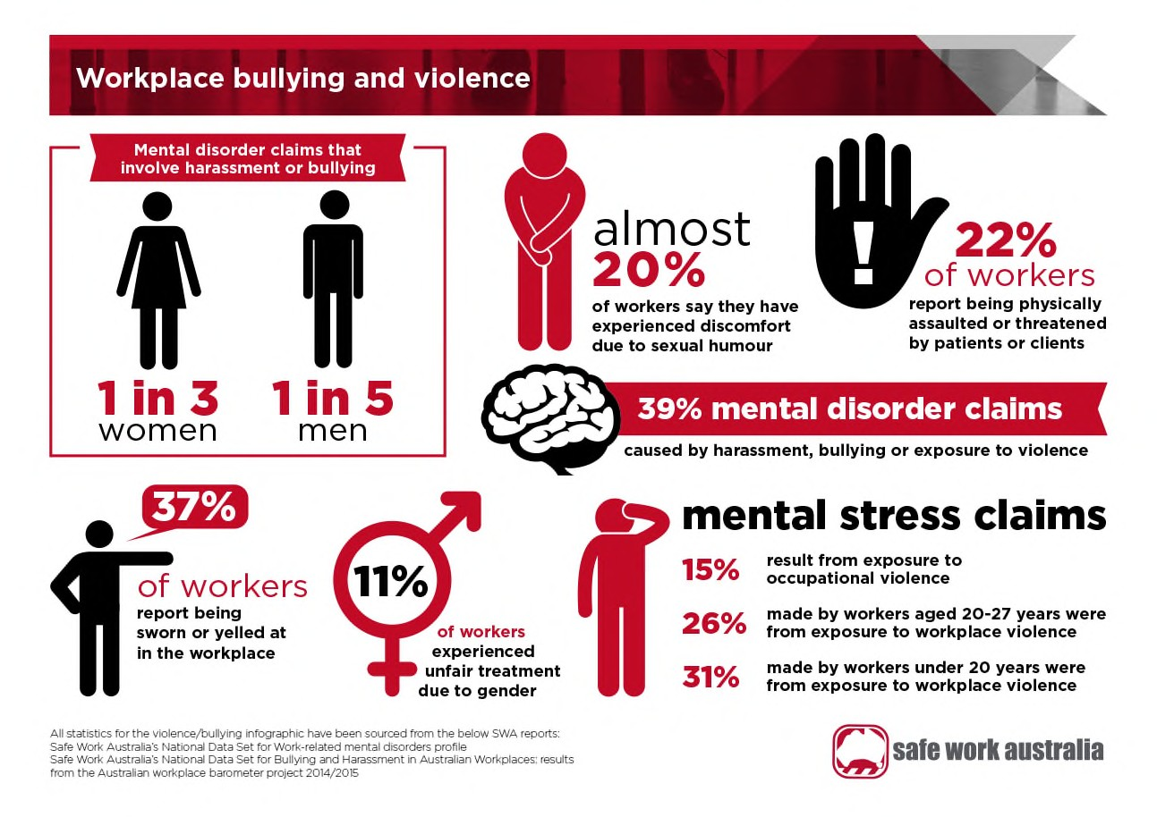
Are you experiencing or witnessing workplace bullying?
To be able to take the most appropriate action it is important to first establish whether the behaviour you are experiencing or witnessing is workplace bullying. Below are some questions that you could consider to determine if certain behaviour amounts to workplace bullying.

Is the behaviour being repeated?
- Repeated behaviour refers to the persistent nature of the behaviour and can involve a range of behaviours over time.
- If it is a one-off incident of unreasonable behaviour, it is not workplace bullying.

Is the behaviour unreasonable?
- Unreasonable behaviour means behaviour that a reasonable person, having considered the circumstances, would see as unreasonable including behaviour that is victimising, humiliating, intimidating or threatening.

If you answer yes to these questions and you consider that your health and safety is being impacted as a result, you may be experiencing or witnessing workplace bullying. There are circumstances when perceived unfair treatment can actually be a result of miscommunication. It can be difficult in times of stress to be objective about what is happening. Therefore, in considering the questions above, it may be helpful to seek the perspective of another person who is not involved, if you need extra support, you can discuss the situation with the WHS safety officer or church elders.
If you are experiencing or witnessing any behaviour that involves violence, for example physical assault or the threat of physical assault, it should be reported to the police.

Next steps if the behaviour does not appear to be workplace bullying
If you remain upset or unhappy because of the behaviour, you could seek advice on strategies that may help resolve the situation and how you are feeling. For example, if the behaviour was reasonable management action or a one-off incident but it still seems unreasonable to you, you could raise your concerns with the person directly or with your supervisor, manager or human resources officer. If necessary, conflict resolution, mediation or counselling services may assist in resolving the issue.

If you believe the behaviour involves unlawful discrimination or sexual harassment, you can seek advice and assistance from your Elders or WHS Officer, the Australian Human Rights Commission, your relevant State or Territory anti- discrimination, equal opportunity or human rights tribunals, the Fair Work Commission, or seek legal advice.
You should continue to monitor the situation over time to ensure it does not escalate to workplace bullying.

Next steps if the behaviour does appear to be workplace bullying
Refer to your workplace policies and procedures. Check whether your workplace has a bullying policy and reporting procedure. The policy should outline how the organisation will prevent and respond to workplace bullying.
Your supervisor, manager or human resources officer should be able to tell you whether there are relevant policies in place. Information on your workplace bullying policy may also be provided in:
induction information, awareness sessions, in-house newsletters or displayed on notice boards documents such as a ‘code of conduct’, or
discussions at staff meetings and in team briefings.

Speak to the other person
If you feel safe and comfortable doing so, calmly tell the other person that you object to their behaviour and ask that it stop. They may not realise the effect their behaviour is having on you or others, and your feedback may give them the opportunity to change their actions. You may also consider suggesting an alternate way for them to behave that is acceptable to you, however whether this is appropriate will depend on the circumstances.
If you choose to deal with the situation personally you should consider:
- acting as early as possible
- raising your concerns informally and in a non-confrontational manner
- not engaging in retaliatory behaviour
- focusing on the unwanted behaviour and how it makes you feel, rather than the person, and
- being open to feedback.
You can ask your WHS Officer, Elders for assistance and support, including accompanying you when you approach the person.

Seek advice
If you are unsure about what to do if you have experienced or witnessed workplace bullying, you may wish to seek advice from an independent person. Advice should be sought from a person who is objective and impartial and who has knowledge of the options available for dealing with workplace bullying. This may include:
- your manager or supervisor
- human resources area
- workplace harassment contact officer
- health and safety representative
- worker representative, and
- employee assistance programs.

Report it
Workplace bullying should always be reported. If you believe you are experiencing or witnessing workplace bullying, you should report it as early as possible. Your employer cannot address the problem if they do not know about it.
You can make a workplace bullying report verbally or in writing, including by:
- informing your supervisor or manager
- informing your WHS Officer or Elders and asking them to make a report on your behalf, or
- using other established reporting procedures.
If your supervisor is the person whose behaviour is concerning you, consider reporting their behaviour through other channels, for example through your WHS Officer or Elder.
If the workplace bullying behaviour has not stopped, you may be able to make a complaint to an external body such as the Fair Work Commission.

What to do if you are accused of workplace bullying
Being accused of bullying behaviour can be upsetting and come as a shock but it is important to be open to feedback from others, and if necessary, be prepared to change your behaviour. Keep the following points in mind:
- Give the complaint serious consideration
If someone approaches you about your behaviour, try to remain calm and avoid aggravating what is likely to be an already difficult situation. Listen carefully to the particular concerns expressed. Discuss how you might work together more effectively. The other person is more likely to share their views with you if you choose a neutral space and ask open questions without attempting to justify your behaviour. Even so, the other person may not be comfortable speaking to you.
- Seek an objective opinion about the behaviour
If you do not understand the complaint or would like a second opinion about your behaviour, discuss the matter with someone you trust. This might be your manager, or a counsellor engaged through your organisation's employee assistance program. Any discussion should be strictly confidential. It is important not to unintentionally escalate the situation by discussing the issue openly. If you believe you are being unjustly accused, or the complaint is malicious, you should discuss this with your manager or human resources officer. It may be that an informal discussion between you, the person making the allegation and a third party will solve the problem.
- Adjust unreasonable behaviour
If you have been made aware that your behaviour is considered unreasonable, stop or modify the behaviour and review what you are doing. If, after careful consideration, you believe that your behaviour is reasonable management action, you should discuss this with your supervisor, manager, or a human resources officer. Even in those circumstances, it may be possible to modify future management action to minimise the risk that others might find it unreasonable. If you are found to have continued to bully someone after their objection to your bullying behaviour was made known to you, your persistence, or the fact that you have not modified your behaviour, is likely to be taken into account in disciplinary or other proceedings.

APPENDIX G – MENTAL HEALTH AND WELLBEING POLICY

Purpose

The purpose of this policy is for [Church Name] to establish, promote and maintain the mental health and wellbeing of all staff and volunteers through workplace practices, and encourage staff and volunteers to take responsibility for their own mental health and wellbeing.
[Church Name] believes that the mental health and wellbeing of our staff and volunteers is key to organisational success and sustainability.

Goals
[Church Name]:
- To build and maintain a workplace environment and culture that supports mental health and wellbeing and prevents discrimination (including bullying and harassment).
- To increase employee knowledge and awareness of mental health and wellbeing issues and behaviours.
- To reduce stigma around depression and anxiety in the workplace.
- To facilitate employees active participation in a range of initiatives that support mental health and wellbeing.

Scope
- This policy applies to all employees of [Church Name], including contractors and volunteers.

Responsibility
All employees and volunteers are encouraged to:
- understand this policy and seek clarification from the safety officer where required
- consider this policy while completing work-related duties and at any time while representing [Church Name]
- support fellow workers in their awareness of this policy
- support and contribute to [Church Name]’s aim of providing a mentally healthy and supportive environment for all workers and volunteers.

All employees and volunteers have a responsibility to:
- take reasonable care of their own mental health and wellbeing, including physical health
- take reasonable care that their actions do not affect the health and safety of other people in the workplace.

Ministry Leaders have a responsibility to:
- ensure that all workers and volunteers are made aware of this policy
- actively support and contribute to the implementation of this policy, including its goals
- manage the implementation and review of this policy.

Communication
[Church Name] will ensure that:
- all employees and volunteers receive a copy of this policy during the induction process
- this policy is easily accessible by all members of the organisation
- employees and volunteers are informed when a particular activity aligns with this policy
- employees and volunteers are empowered to actively contribute and provide feedback to this policy
- employees and volunteers are notified of all changes to this policy.

Monitoring and review
[Church Name] will review this policy in accordance with the WHS Review protocols
Effectiveness of the policy will be assessed through:
- feedback from workers, volunteers, Safety Officer and Elders
- review of the policy to determine if objectives have been met and to identify barriers and enablers to ongoing policy implementation.

APPENDIX H – SMOKE FREE POLICY
The impact of smoking in the workplace
This Photo by Unknown Author is licensed under CC BY-SA
Smoking is a leading cause of preventable death and disease in Australia. Smoking greatly increases your risk of suffering from potentially deadly conditions, including a range of cancers, heart disease and respiratory illness. Environmental tobacco smoke (passive smoking) can also harm your health. Smoking in indoor and enclosed public spaces is now banned across Australia. Maintaining a smoke-free work environment is essential to ensuring the health and wellbeing of everyone in the workplace.

Mission statement
[Church Name]
- Will be smoke-free at all times
- Will support workers who want to quit
- Will protect workers and visitors from environmental tobacco smoke (passive smoking)
- Will inform workers about the health risks associated with smoking

Objectives and strategies
[Church Name] will eliminate smoking and passive smoking in the workplace by:
- Ensuring all workers and visitors are aware of the smoke-free policy
- Marking the workplace with smoke-free signs
- Ensuring that the smoke-free policy is included in other relevant policies e.g. motor vehicle and recruitment policies
- Ensuring that all church-related events (both on and off site) are non-smoking events
- Providing support to workers wanting to quit smoking, where possible; this may include providing subsidised or free quit smoking programs or subsidised nicotine replacement therapy

Increase knowledge and awareness among workers and volunteers of the health risks of smoking by:
- Providing information (brochures) to employee or volunteers. (For a range of quit smoking resources, visit www.quit.org.au)
- Provide information on quit smoking tools such as Fresh Start smoking cessation courses and Quitline when appropriate.

Scope and responsibilities
This policy applies to all workers, volunteers and visitors to [Church Name]. Employees are required to:
- Understand and comply with this policy at all times while in the workplace or representing [Church Name]
- Ensure their visitors are aware of the policy
- Inform management if they believe the policy has not been upheld

The Church Safety Officer and Elders are responsible for:
- Making sure all workers and visitors are made aware of this policy
- Encouraging a workplace culture that supports workers who want to quit smoking
- Managing the implementation and review of this policy

Communication
[Church Name] will ensure that:
- The policy is communicated within the job application process
- All workers receive a copy of this policy during the induction process
- This policy is easily accessible to all members of the organisation
- Workers are informed when a particular activity aligns with this policy
- Workers have the power to actively contribute to and provide feedback on this policy
- Workers are notified of all changes to this policy
- Successes are celebrated within the workplace

Monitoring and review
This policy will be reviewed in accordance with the WHS Policy review protocols. This process will involve:
- Assessing progress and seeing if objectives have been met
- Providing workers with the opportunity to give feedback
- Considering all feedback and suggestions and making changes as required
- Communicating the reviewed policy to workers

APPENDIX I – DRUG AND ALCOHOL POLICY

[Church Name] is committed to achieving a healthy and safe working environment for our employees, volunteers and visitors. As such, we recognise that alcohol, drug and other substance abuse by employees can have serious adverse effects on their own health and safety of other others. Employers have a duty of care under the Occupational Safety and Health Acts to protect workers from any known harms. This includes the short and long term risks associated with drugs and alcohol. Creating a workplace that prevents the use of drugs and alcohol within the workplace can positively impact on the health and safety of workers.

[Church Name] is committed to ensuring the health, safety and welfare of all employees and to prevent and reduce harm associated with people being impaired by drugs or alcohol at work. These guidelines apply to all employees, volunteers and contractors.

Responsibilities
It is the responsibility of the Safety officer to:
  - ensure these guidelines are enforced on a day to day basis;
  - direct any employee, volunteer or contractor reasonably suspected of being under the influence of drugs or alcohol away from the work area;
  - direct employees or volunteers to a medical practitioner nominated by the church where it is reasonably suspected that they are under the influence of drugs or alcohol;
  - arrange for transport home for any employee or volunteer under the influence of drugs or alcohol;
  - counsel employees and volunteers who are found to be in breach of these guidelines; and
  - authorise appropriate assistance for an employee or volunteer whose performance is affected by drugs and/or alcohol.

It is the responsibility of employees, volunteers and contractors to:
- comply with these guidelines; and
- inform the Church and request assistance if they have an ongoing drug or alcohol problem or addiction that is likely to adversely affect their work performance.

Consumption of alcohol/drugs
Employees, volunteers and Contractors should not be under the influence of alcohol or drugs during working hours and must at all times carry out their duties and responsibilities in a safe manner. If anyone suspects that another employee, volunteer or contractor is working while impaired by or under the influence of alcohol or drugs, he/she should immediately report this situation to the Safety Officer.

An employee or volunteer on prescribed medication should check with their doctor to ascertain whether use of the drug will impact on performance, particularly the impact on their ability to operate machinery or a motor vehicle. If this is the case, the employee or volunteer should advise the Safety Officer.

Employees and volunteers must observe statutory limits for blood alcohol content whilst driving:
- any Church vehicle, or
- any vehicle on employer business to work, from work, during work or to and from any work-related function.

A modest consumption of alcohol is acceptable at approved functions. However, employees and volunteers are responsible for the amount they choose to drink at such functions.

Employer support
We view alcoholism and drug use as treatable illnesses. In appropriate situations, where an employeeʼs or volunteer’s performance and well-being has been adversely affected by alcohol or drug use, the Church will assist the employee or volunteer via referral to treatment programs.

Breach of these guidelines
Where an employee, volunteer or contractor breaches or is reasonably suspected of having breached this policy, the employee, volunteer or contractor will be given an opportunity to explain his or her actions. Where no satisfactory explanation is given, the matter will be treated as misconduct. Breach of these guidelines may result in disciplinary action, up to and including dismissal. Where an employee or volunteer is referred to a treatment program, the Church may at its discretion treat the absence from work for treatment as paid sick leave entitlements. When an employee has no outstanding paid sick leave, they may be entitled to leave without pay or may be able to utilise other accrued leave entitlements. The Church reserves the right to terminate employment or volunteering for an individual if treatment is not undertaken or is unsuccessful.

APPENDIX J – CONTACT POINTS

Jurisdiction | Regulator | Telephone | Website
New South Wales | SafeWork NSW | 13 10 50 | safework.nsw.gov.au
Victoria | WorkSafe Victoria | 1800 136 089 | worksafe.vic.gov.au
Queensland | WorkSafe Queensland | 1300 369 915 | worksafe.qld.gov.au
South Australia | SafeWork SA | 1800 777 209 | safework.sa.gov.au
Western Australia | WorkSafe WA | 1300 307 877 | commerce.wa.gov.au/WorkSafe/
Australian Capital Territory | WorkSafe ACT | 02 6207 3000 | worksafe.act.gov.au/healthsafety
Tasmania | WorkSafe Tasmania | 1300 366 322 (Tas) | worksafe.tas.gov.au
Northern Territory | NT WorkSafe | 1800 019 115 | worksafe.nt.gov.au
Commonwealth | Comcare | 1300 366 979 | comcare.gov.au

APPENDIX K – PREPARING AN EMERGENCY PLAN

Your emergency plan must include:
- an effective response to an emergency
- evacuation methods
- notifying emergency services at the earliest opportunity
- medical treatment and assistance
- effective communication with everyone at the workplace
- how often the emergency procedures are to be tested
- instruction and training about implementing the emergency procedures.
- If you share a workplace with a number of other businesses – eg in a shopping centre or on a construction site – you must consult with those businesses when preparing an emergency plan.
Emergency Management Plan - checklist
As a Person Conducting a Business or Undertaking (PCBU) you are required, under the new WHS legislation, to be prepared for emergency situations that may arise at your church. Putting together an Emergency Management Plan will help ensure you and your workers are well prepared. Use the following checklist to help develop your plan.
Responsibilities
- Is there a plan on emergency response
- Has the plan been approved by the Elders or Team Leaders?
- Has the plan been distributed to all who need to know
- Who/which people can declare a full evacuation:
- Who/which people can declare an emergency over:
- Is the emergency plan for the church reviewed to ensure it remains effective
- Has someone with appropriate skills been made responsible for specific actions in an emergency (e.g. appointment of an area warden)
- Is there someone responsible for making sure all workers and others in the workplace (e.g. contractors, customers
and visitors) are accounted for in an evacuation? You may use attendance records for this purpose
- Are specific procedures in place for critical functions such as power or gas isolation

Emergency Contact Details
- Are emergency contact details (relevant to the types of possible risks, e.g. the Ambulance Service, Fire and Rescue, the Rural Fire Service, the Police Force, the State Emergency Service, displayed at the workplace in an easily
accessible location?
- Are contact details updated regularly?
- Who will notify emergency service organisations?

Work Environment
- Have you considered what type of emergencies might occur in your workplace when preparing the emergency plan? Consider emergencies arising from your workplace, and also from outside your workplace
- Have the Safety Officer, workers, neighbouring businesses (if relevant) been consulted in the development of the
plan
- Is there a mechanism, such as a siren or bell alarm, for alerting staff of an emergency?
- Is there a site plan that illustrates the location of fire protection equipment, emergency exits and assembly points
- If there is a site plan, is it posted in key locations throughout the workplace
- Are the following documents displayed in the workplace: evacuation plan, emergency contacts, first aid equipment
locations
- Are all exits, corridors and aisle ways kept clear of obstructions and does the workplace have illuminated exit signs
- Are procedures in place for assisting mobility impaired people
- Are emergency procedures regularly tested as per requirements in the plan

Information, training and instruction
- Are relevant workers informed, trained and instructed in relation to implementing the emergency procedure

Fire Protection and Fire fighting Equipment
- Does the workplace have fire protection and fire fighting equipment
- Is the fire protection and fire fighting equipment suitable for the types of risks at the workplace (e.g. foam or dry powder type extinguishers for fires that involve flammable liquids)

- Is equipment regularly tested by a local fire authority or fire equipment supplier
- Is equipment kept clear of obstructions
- Are workers trained to use fire extinguishers where required and do they know what type of extinguisher to use for
different types of fires

Bushfire Danger Ratings
- If your business is located in a bushfire danger area, have you reviewed your existing fire risk controls to ensure they
will be effective in bushfire danger conditions
- Have you reviewed your workplace emergency evacuation procedures for days of declared fire ratings (e.g. code red catastrophic, extreme etc) to include matters such as:
  - safe exit routes (i.e. which roads are open and closed)
  - the closest designated ‘safe place’
  - consistency with the evacuation procedures of the relevant local authorities (e.g. Rural Fire Service and police)
  - - employee access to reliable communication equipment
- Have your workers been trained in the bushfire emergency evacuation procedures
- If your workers are required to travel into areas where fire ratings such as code red or extreme may be declared, have you developed appropriate policies and procedures for when such declarations are made

First Aid
- Has first aid equipment been provided for the workplace
- Does each worker at the workplace have access to the equipment, and access to facilities for the administration of first aid
- Have an adequate number of workers been trained to administer first aid at the workplace, or do workers have
access to an adequate number of other persons who have been trained to administer first aid
- Have you conducted a first aid assessment

Neighbouring Businesses
- Have you considered neighbouring businesses and how you will let them know about an emergency situation should
one arise
- Have you considered the risks from neighbouring businesses (eg fire from restaurant / takeaway food outlets; Q fever from cattle yards; truck accidents on major roads etc)

Post Incident Follow-Up
- Are there procedures to notify WorkCover about an incident where necessary (go to your state safe work website to see if incident is notifiable)
- Are there procedures to ensure the cause of the emergency is determined and action is taken to prevent a similar
incident occurring again
- Are there procedures to ensure the welfare of workers after an emergency or an incident, such as medical treatment or trauma counselling

Testing and Review
- Are emergency practice runs (eg evacuation drills) undertaken to assess the effectiveness of the Emergency
Management Plan (EMP).
- Is someone responsible for documenting and retaining results of EMP practice runs
- Is someone responsible for reviewing the EMP and informing staff of any revisions

Be sure to customize this list with items specific to your church needs.

