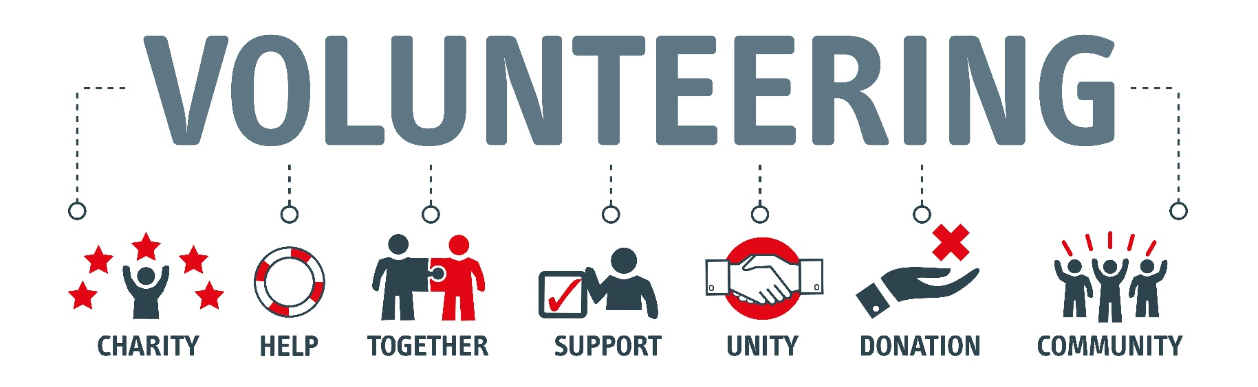

VOLUNTEER’S AGREEMENT
Acknowledgement: | I acknowledge I have be given a copy of the church’s:  - Induction Manual  - Volunteers Code of Conduct  - WHS Policy  - Child Protection Policy  - Equal Opportunity, Anti-Discrimination, Anti-Harassment and Bullying Policy  - Privacy and Confidentiality Policy, and  - Relevant offsite Induction Manuals, where applicable.  Have read the manuals/policies and agree to abide by them.  I also declare that:  - I have never been convicted of any criminal offence.  - I have never been charged with any criminal offence in relation to physical or sexual abuse of any kind.  - I have never had an allegation of physical or sexual abuse made against me to the police, authority, church or other community organisation.  - There is nothing in my past that would call into question my suitability to be entrusted with the care of youth, children or vulnerable children  I confirm the information I have supplied on this form is true and correct to the best of my knowledge. Should it be found the answers are untrue, I understand that this may be grounds to remove me from the ministry/activity.
Date:
Name:
Gender:
Address:
Telephone:
Mobile Phone:
Email Address:
Medical Conditions:
Allergies:
Behavioural Issues:
Next of Kin:
Name:
Relationship:
Address:
Mobile Phone:
Email Address:
Signature of Volunteer

