01.01.17

AGREEMENT V3

PASTORAL EQUIPPING GRANT (PEG)

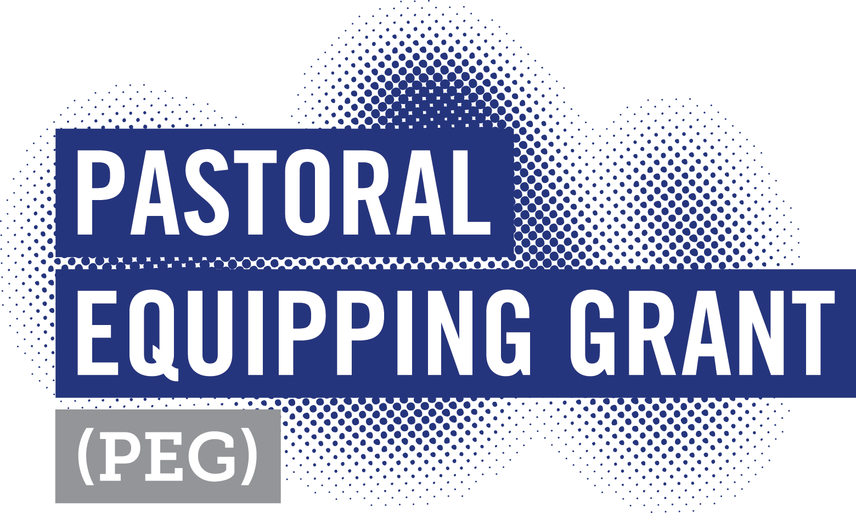

THIS AGREEMENT is made on the day of 20
Between the Parties:
Party 1:
Provider: | CCCVAT MINISTRIES LTD [CCCVAT]
ABN: | 82 629 507 099
Postal Address: | PO Box 521, Blackburn VIC 3130
Party 2:
Church:
ABN:
Address:
Party 3:
Pastor:
Address:

BACKGROUND:
- CCCVaT is an association that aids and assists Churches grow the Kingdom of God,
- CCCVaT is the promoter and manager of the program titled Pastoral Equipping Grant [PEG].
- The Church has applied for a PEG according to the terms and conditions outlined in the PEG Guidelines and Agreement and CCCVaT has agreed to provide the grant subject to these terms and conditions.
- The Pastor has agreed to role assigned by the Church accordingly to its strategic plan, the PEG guidelines and terms and conditions of this agreement.
- The Parties signatures to this agreements binds them to the terms and conditions of same.

The parties to this agreement agree as follows;
OPERATIVE PART:
- DEFINITIONS:
In this Agreement unless repugnant to or inconsistent with the context, the following meanings shall apply:
Agreement – this Pastoral Equipping Grant (PEG) Agreement.
Business Day - means a day other than a Saturday, Sunday, Public Holiday or Bank Holiday
where an act is to be performed or payment made.
Christian Community Churches of Victoria and Tasmania (CCCVAT) - owner and operator of PEG.
Church – an associate Church or Church listed with the Christian Brethren Trust.
Commencement Date – the date from which the terms and condition of this Agreement apply, as set out in Schedule 1.
Confidential Information – means any correspondence or information pertaining to the Application, Agreement and program not available in the public domain or so marked.
Force Majeure - circumstance beyond the reasonable control of the Parties, which results in a Party being unable to observe or perform on time an obligation under this Agreement.
Guidelines – terms and conditions of PEG.
PEG - Pastoral Equipping Grant (PEG).
Intellectual Property Rights - all rights present and future, copyright, trademarks, designs, patents and confidential information and all other rights conferred by statute, common law and/or equity and also includes the right to register any such rights.
Pastor – person under the PEG.
Mentor – person nominated on the Application, who will mentor the Pastor in the ministry of the Church.
Ministry – duties performed by Pastor as defined by the Church’s strategic plan, PEG guidelines and this Agreement.
Party or Parties – signatories or parties to this agreement.
Supervisor – person nominated on the Application, who will supervise the Pastor in the ministry of the Church.
Term means the period this agreement applies, as detailed Schedule 1.
Third Party Provider an entity employed by CCCVaT to manage or assist with PEG grant or any part thereof.
Trade Marks – the marks of the Christian Community Churches of Victoria and Tasmania, The Church and PEG Program. (as the context dictates).
2: INTERPRETATION:
In this Agreement:
  - Words importing the singular include the plural and vice versa.
  - A reference to any Party or other person includes that person's successors and permitted assigns.
  - A reference to a statute, ordinance or other legislation includes any amendment, replacement or re-enactment for the time being in force and includes all regulations, by-laws and statutory instruments made thereunder.
  - A reference to this or any other document includes a reference to that document as amended, supplemented, novated or replaced from time to time.
  - A reference to a recital, clause or Schedule is a reference to a recital, clause or Schedule of this Agreement.
  - A reference to a month means a calendar month.
  - A reference to a person includes a natural person, corporation, partnership, trust, estate, joint venture, sole partnership, government or governmental subdivision or agency, association, co-operative and any other legal or commercial entity or undertaking,
  - Where a Party comprises two or more persons, any agreement or obligation to be performed or observed by that Party binds those persons jointly and each of them severally, and a reference to that Party is deemed to include a reference to any one or more of those persons.
  - The headings in this Agreement do not affect its interpretation.
  - The recitals and the schedules form part of this Agreement.
  - A reference to $ is to Australian currency.
3: SCOPE OF THIS AGREEMENT:
During the Term of this Agreement:
- CCCVaT and the Church will co-fund the PEG grant.
- The Church will employ the Pastor in the Ministry of The Church.
- The Pastor shall work in the Ministry of the Church and as instructed by the Supervisor or leadership team.
4: TERM:
This Agreement commences on the Commencement Date and continues for the Term until concluded or terminated in accordance with this Agreement as per Schedule 1.
5: ACKNOWLEDGEMENT:
The Church and Pastor acknowledge and agree:
  - PEG grant:
The funds from the PEG Grant are to be used solely for the purpose of employing the Pastor over the period of the grant, including the cost of superannuation guarantee levy, work cover and regulatory leave requirements and for no other purpose.
  - PEG operational provisions:
- CCCVaT may operate and conduct the PEG grant in such manner as it determines in its
absolute discretion.
- The PEG grant or any part thereof may be varied, amended or terminated by CCCVaT
from time to time by notice to The Church and Pastor.
- CCCVaT will use its best endeavour to consult with The Church and Pastor on any significant proposed changes to the terms and conditions of the PEG grant.
- CCCVaT will give The Church and Pastor 30 days’ written notice where variances are made.
- The PEG grant may be operated by CCCVaT using Third Party Providers.
5.3: CCCVaT’s maximum contribution for the Term of this Agreement is detailed Schedule 1.
6: WHAT CCCVaT WILL DO:
6.1 CCCVaT will:
- Subject to the Church and Pastor meeting its obligations under this Agreement, co-fund the PEG grant at rate specified in Schedule 1 for the period of the Term.
6.2 Payment of CCCVaT contribution to the PEG grant is detailed in Schedule 1.
(Advances and installments will be made on a Business Day)

7: WHAT THE CHURCH WILL DO:
The Church will:
  - Employ the Pastor in the Ministry of The Church.
  - Be responsible for all the regulatory requirements expected of an employee.
  - Co-fund the PEG grant at the rate specified in Schedule 1, for the period of the Term.
  - Ensure the Pastor is appropriately supervised by the nominated supervisor.
  - Ensure the Pastor is appropriately mentored by the nominated mentor.
  - Pray for the Pastor on a regular basis.
  - Develop, equip and empower the Pastor.
  - Ensure the Pastor is trained in all Church policy, including OHS training.
  - Report on the Pastor’s progress to CCCVaT on the approved form at the agreed
times as detailed Schedule 1.
  - Ensure The Church meets and complies with all regulatory requirements capable of being applied to its operation.
  - Monitor the Pastor’s and Church’s performance against the strategic plan and ensure failings are addressed and alert CCCVaT of such.
8: WHAT THE PASTOR WILL DO:
The Pastor will:
  - Provide the Church with:
- copy of Working with Children Check; and
- copy of ‘National Criminal History Check’ dated within two years of the Commencement of the PEG grant; and
- An electronic portrait of no less than 300dpi or 1mb.
  - Undertake Ministry duties as directed by the Church and its appointed Supervisor.
  - Undertake training as directed by the Church.
  - Attend conferences/conventions hosted by CCCVaT, as directed by the Church and CCCVaT.
  - Report on PEG grant on the approved form and at the prescribed times, detailed Schedule 1.
  - Conduct them self at all times in accordance with Christian beliefs and values.
  - Abide at all times by the terms and condition of the strategic plan, PEG guidelines and this Agreement.
9: COMPLAINT HANDLING:
9.1 Where the Church or Pastor has a complaint against the other which cannot be
satisfactorily resolved, the Church or the Pastor many refer the matter to CCCVaT:
- CCCVaT shall do everything reasonably possible to remedy the complaint between the Parties.
- In the event the Church or Pastor are unable to agree on a solution, CCCVaT will make a resolution which the Parties will abide by.
9.2 Where a complaint exists with the Church or Pastor with CCCVaT which is not able to be
satisfactorily resolved, the Parties agree to appoint a mutually acceptable mediator to
mediate on the dispute and the Parties are to abide by any recommendation the mediator
proposes.
10: INTELLECTUAL PROPERTY RIGHTS:
10.1 The Church and Pastor acknowledge that all Intellectual Property Rights in the PEG grant
are vested in and are exclusively owned by CCCVaT.
10.2 This clause shall survive the termination or expiration of this Agreement.
11: INDEMNITITES AND INSURANCE:
11.1 The Church and Pastor releases and indemnifies CCCVaT, its directors, officers, employees, agents, contractors and related bodies corporate against all actions, claims, demands and proceedings which may be instituted against all Parties and/or against all liability, losses, damages, costs, expenses (including consequential and special loss or damage) which may be suffered or incurred or which may arise in any manner, directly or indirectly, whether during the term of this Agreement or after the termination or expiration of this Agreement, from or in connection with:
- The conduct of the Pasties to this agreement.
- The supply of goods or services by or on behalf of the CCCVaT to Parties.
- The promotion of the PEG grant.
- Any changes to the PEG grant.
- Any failure of performance or wrongful performance by the Parties of any of their obligations under this Agreement.
- Any negligence or willful misconduct of by the Parties in connection with this Agreement.
- Any unauthorised use or infringement of CCCVaT’s Intellectual Property Rights, caused directly or indirectly by the Parties.
11.2 The Church shall maintain public liability insurance and other related insurance for the safeguard of its employees and directors/Pastors.
11.3 This clause shall survive the termination or expiration of this Agreement.
12: TRADE MARKS AND LICENCES:
Subject to the terms of this Agreement, CCCVaT and the Church each grants the other a royalty free, non-exclusive, non-transferable, revocable, non-sub licensable, licence for the term of this Agreement to use the other Parties Trade Mark/s in marketing the PEG grant.
13: CONFIDENTIALTY:
13.1 The Parties may not disclose any information on the PEG grant or this Agreement, which
is not already in the public domain, without the consent of the other Parties.
13.2 This clause shall survive the termination or expiration of this Agreement.
14: TERMINATION:
CCCVaT may terminate this Agreement without liability or cause by giving 30 days written notice to the Parties at any time where:
- The Church resigns from the Association.
- The Church is expelled from the Association.
- The Church is insolvent or risks being wound up.
- The Church fails to perform or breaches its obligations under the Guidelines or this Agreement.
- The Church falls short of achieving the KPI’s as detailed in the strategic plan.
- The Church fails to report on the prescribed form in a timely manner.
- The Pastor’s National Criminal History Check reveals a criminal activity or conviction that in the opinion of The Church or CCCVaT is unacceptable for the role.
- The Pastor is found guilty of a criminal offence.
- The Pastor fails to be granted have their Working with Children Check renewed.
- The Pastor is declared or declares bankruptcy.
- The Pastor behaves in a manner contrary to Christian beliefs or values.
- The Pastor discredits The Church or CCCVaT.
- The Pastor fails to fulfil or breaches any obligations under the Guidelines or this Agreement.
15: PRIVACY:
15.1 The Parties will comply with all relevant laws in relationship to privacy and data collection
and not disclose any personal information without the consent of the Parties.
15.2 The Pastor consents that The Church may use personal or disclosed information for
the purpose of meeting its obligations under this Agreement.
  - The Parties consent that CCCVaT may use personal or disclosed information for meeting its obligations under this Agreement, its Church directory included in its website (accessible by username and password) and for its own marketing purposes where appropriate.
  - This clause shall survive the termination or expiration of this Agreement.
16: FORCE MAJEURE:
  - Neither Party will be liable for any delay or failure to perform its obligations pursuant to this Agreement, if such delay is due to Force Majeure.
  - If a delay or failure of a Party to perform its obligations is caused or anticipated due to Force Majeure, the performance of that Parties obligations will be suspended.
  - If a delay or failure by a Party to perform its obligations due to Force Majeure exceeds sixty (30) days, either Party may immediately terminate the Agreement on providing notice in writing to the other Party.
17: STATUS OF THE PARTIES:
Nothing in this Agreement is to be construed as creating a partnership or joint venture or relationship of agency or employment between the Parties.
The Church or Pastor are not accountable beyond the terms and condition of this agreement
to CCCVAT and CCCVAT is not responsible for the conduct of the Parties.
18: NOTICES:
Any notice, demand or other communication (“Notice”) to be served or required to be made pursuant to this Agreement, is to be in writing and either served by post to the addresses as detailed in this Agreement or emailed to the Parties addresses as detailed at the start of this Agreement or Schedule 1.
19: PROVISIONS SEVERABLE:
If any provision of this Agreement is invalid or unenforceable in any respect, the validity, and enforceability of the remaining provisions will not be affected and such invalid or unenforceable provision are to be severed from this Agreement.
20: GOVERNING LAW:
20.1 This Agreement and the transactions contemplated by it are governed by and construed in accordance with the laws of the State of Victoria, Australia and the Parties irrevocably submit to the exclusive jurisdiction of the courts in that State.
20.2 This clause shall survive the termination or expiration of this Agreement.
21: VARIATION:
No part of this Agreement may be amended or modified unless reduced to writing making specific reference to this Agreement and signed by the Parties.
22: ENTIRE AGREEMENT:
This Agreement sets out the entire agreement and understanding between the Parties with respect to the subject matter of this Agreement and supersedes all prior agreements, understandings and representations.

SIGNATORIES TO AGREEMENT:
The Parties to this Agreement declare that the information provided on all relevant forms used to approve this application and details listed in this Agreement are to the best of their knowledge true and correct.

A: The Church (to be signed by a person authorised by the Church to do so)
Date:
Name:
Position:
Signature:

B: The Pastor (to be signed by the Pastor in the presence of the Church signatory)
Date:
Name:
Signature:

C: CCCVaT (to be signed by a person authorised by CCCVaT to do so.)
Date: | Day/Month/Year
Name: | Paul Gould
Position: | General Manager
Signature:

SCHEDULE 1:
a: Commencement:
b: Term: | 36 months from commencement to conclusion.
c: Contribution: | Year 1 ()  - The Church  - CCCVaT  Year 2 ()  - The Church  - CCCVaT  Year 3 ()  - The Church  - CCCVaT
 |  | $
 |  | $
 |  | $
 |  | $
 |  | $
 |  | $
d: Payments | CCCVaT annual contribution will be paid in advance over four quarters.
e: Reporting:
- The Church: | Annual Progress Reports
- Pastor: | Annual Progress Report
f: Supervisor and Mentor:
- Supervisor:
- Mentor
g: Email Addresses:
- CCCVaT: | office@cccvat.com.au
- The Church:
- Supervisor
- Mentor
- Pastor:

