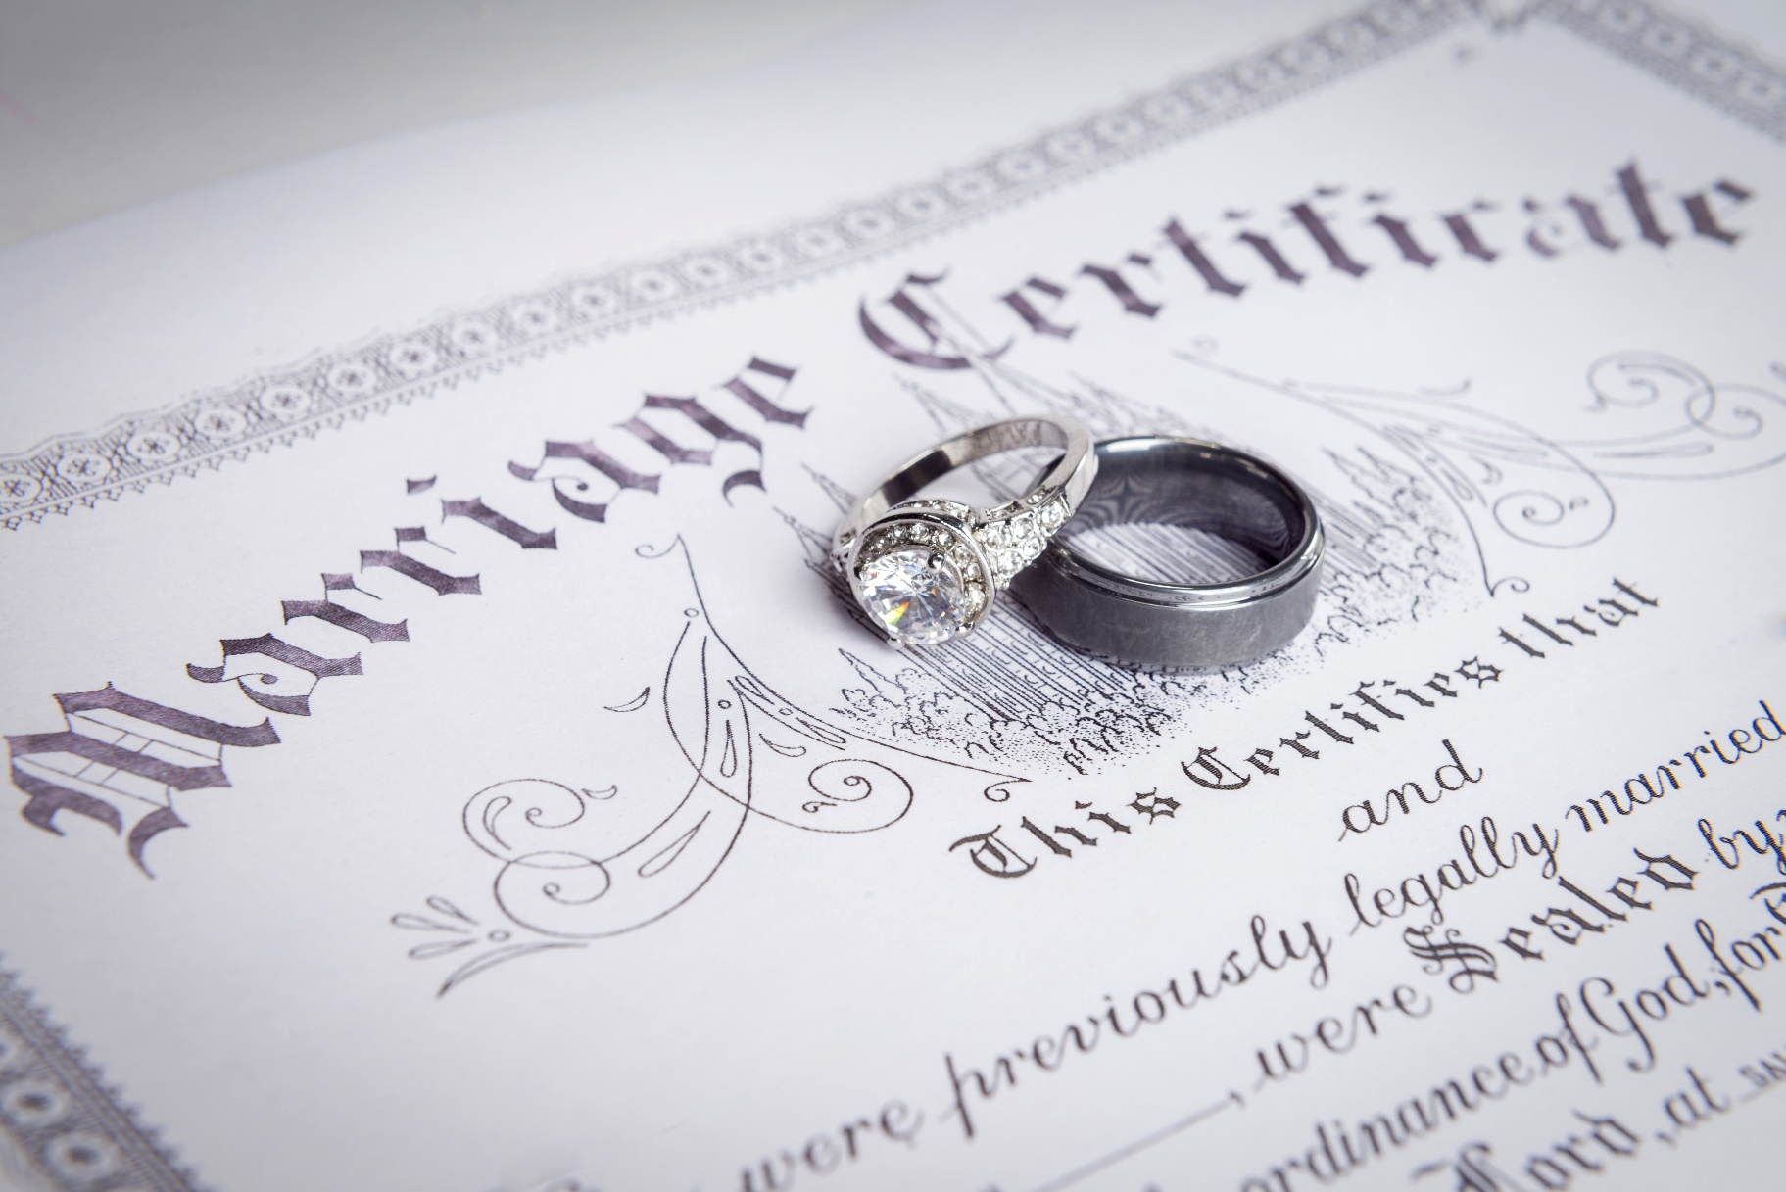

CCCAUST
MARRIAGE CELEBRANT – LICENCE APPLICATION
MINISTERS OF RELIGION
01.01.20 V1

CONTENTS
 | MARRIAGE LICENSE APPLICATION |  | Page
 | 1 | Preface: | 3
 | 2 | Criterion: | 3
 | 3 | Required Competencies: | 4
 | 4 | Process for Appointing New Marriage Celebrants: | 5
 | 5 | Application for Registration as Marriage Celebrant: | 5
 | 6 | Applicant Details and Declaration: | 5-6
 | 7 | Section 1 - Questionnaire for Marriage Celebrant Applicants: | 7-8
 | 8 | SECTION 2 - Questionnaire for Elders Commending Marriage Celebrant Applicants: | 9-10
 | 9 | Acknowledgement – Elders: | 11

MARRIAGE CELEBRANT - LICENSE APPLICATION

PREFACE:
- CCCAust is a recognised denomination by the Attorney General’s Department for the purpose of registering Ministers of Religion as Marriage Celebrants. This enables CCCAust’s state bodies to nominate and register competent ministers to perform these duties in their respective states.
- CCCAust requires that Ministers wishing to register as a Marriage Celebrant under its registered denomination, are appropriately prepared for the role and conform to all the requirements detailed in CCCAust Marriage celebrant Information Guidelines for Ministers of Religion and this application.
- All CCCAust Marriage Celebrants are representatives of our churches. As local church representatives CCCAust Marriage Celebrants must solemnize all marriages in accordance with the:
- Australian Marriage Act 1961
- Marriage Regulations 2017 and its amendments,
- CCCAust Marriage Rites and conventions and tenets of the applicant’s church.
- CCCAust Code of Conduct.
The CCCAust Marriage Rites represent the minimum requirements for solemnizing a marriage under the rites of Christian Community Churches of Australia.
Individual church elderships/leaderships may require celebrants to include additional elements.

CRITERION:
Marriage Celebrants need to conform to the Government’s legal requirements by filling in documents and submitting these on time to record the intent and act of marriage. [Time is of the essence]
Under the Marriage Act and in accordance with CCCAust criterion, a person is entitled to registration as a Marriage Celebrant if:

The person is engaged as a Minister of Religion with a recognised CCCAust church;

The Minister of Religion is nominated for registration by their church;

The Minister of Religion is nominated by the nominating authority for the state the church is located in;

The Minister of Religion is a citizen or permanent [CCCAust requirement] resident in Australia; and

The Minister of Religion has attained the age of 21 years.

REQUIRED COMPETENCIES:

Prior to applying to become a Marriage celebrant:
- Have read and comprehended all relevant versus in the Bible concerning marriage.
- Have read and comprehended – CCCAust Marriage Celebrant Information Guide
- Have read and comprehended - Marriage Act 1961 - C2018C00441
- Have read and comprehended - Marriage Regulations 2017 - F2017L01359
- Have read and comprehended - Marriage Amendment (Definition and Religious Freedoms)
Act 2017

Have read and comprehended – CCCAust Marriage Rites

Have read and comprehended – CCCAust Code of Practice – Marriage Ceremony

Have been trained by a recognised religious training organization in Marriage Celebrancy.

Has been advised by the church on its applicable tenets regards marrying a couple.

Either prior to or post application:

Have been trained by an approved religious training organization in Pre-Marriage
Counselling.

Post Application:

Undertake every year four hours of professional development relevant to marriage.

Christian Tenets:

Only marry in accordance with Christian tenets concerning marriage.

Only marry in accordance with the marriage tenets of the church.

Pre-Marriage Counselling:

Provide all couples with a copy of the marriage tenets of the church and CCCAust Marriage Rites.

Counsel all couples on marriage in accordance with the training received on Pre-Marital Counselling.

Performing the Marriage Ceremony:

Solemnize the marriage in accordance with CCCAust Code of Practice.

Solemnize the marriage in accordance with CCCAust Marriage Rites.

PROCESS FOR APPOINTING NEW MARRIAGE CELEBRANTS:

The applicant is to obtain the endorsement of the leadership/board of the church, which is to be stated in a letter to the state body.

The applicant is to complete the Nomination for Registration of Minister of Religion form for their state and forward to the state body.

The applicant is to complete CCCAust Marriage Celebrant – Licence Application and forward to the state body.

The state body, having received the forgoing documentation and assessed that the applicant has met all the requirements of CCCAust, shall apply to the respective Births, Deaths and Marriage authority in its state.

APPLICATION FOR REGISTRATION AS MARRIAGE CELEBRANT:
To apply:
- Complete the registration forms below:
- Items 6 and 7 are to be completed by the applicant.
- Items 8 and 9 are to be completed by the Elders/Leaders/Board of the church, and
- Provide copy of the endorsement from your church.
- Post, do not email, the completed form to your state authority.

APPLICANT DETAILS AND DECLARATION:

Please complete all sections in type [preferably] or print.

Name:
First: |  |  | Middle: |  |  |  |  | Last:

Address:
 |  |  | State: |  |  |  |  | Post Code:

Email:
Phone: |  |  |  | Mobile:

Date Birth:
I am an Australian Citizen/Resident? |  |  |  | Yes |  |  |  |  |  | No

Please attach a copy of your birth certificate and or residency.
I am over 21 years of age? |  |  |  | Yes |  |  |  |  |  | No
I have read and comprehend the following? |  |  |  |  |  | Yes |  |  |  |  |  | No
- All relevant versus in the Bible concerning marriage.
- CCCAust Marriage Celebrant Information Guide
- Marriage Act 1961 - C2018C00441
- Marriage Regulations 2017 - F2017L01359
- Marriage Amendment (Definition and Religious Freedoms) Act 2017

CCCAust Marriage Rites

CCCAust Code of Practice – Marriage Ceremony

The applicable tenets regards marriage of church I attend.

I have completed training in Marriage Celebrancy?

Provider?
Course? |  |  |  |  |  |  | Date?

Please attach a copy of the certificate of completion.

I have completed the following pre-marriage training course:

Provider?
Course? |  |  |  |  |  |  |  | Date?

Please attach a copy of the certificate of completion.

I agree to undertake a minimum of 4 hours professional development each year.
Yes |  |  |  |  | No

I acknowledge my accountability to CCCAust, the state body and Elders/Leaders/Board of the church I attend.

Church?

Date Signed?

Signature:

QUESTIONNAIRE FOR MARRIAGE CELEBRANT APPLICANTS:
Please answer these questions in the space below, but feel free to add comments at the foot or on a separate sheet.
1: Why do you wish to be appointed as a marriage celebrant?
2: Why do you think you are suited to be appointed as a marriage celebrant?
3: Please outline your experience in leading public meetings.
4: What experience and training have you had in counselling people?
5: What so you understand your church’s marriage policy to be in relation to issues such as marrying couples who have lived together, those who are not members of the church and those who have been divorced?
6: What areas of assistance do you think you will need in fulfilling the role of marriage celebrant?

QUESTIONNAIRE FOR ELDERS/LEADERS/BOARD COMMENDING MARRIAGE CELEBRANT APPLICANTS:
Please answer these questions in the space below, but feel free to add comments at the foot or on a separate sheet.
1: Why do you wish to appoint this persons as a marriage celebrant?
2: Why do you think the applicant is suited to be appointed as a marriage celebrant?
3: What public role does the applicant play in your church?
4: What experience and training has the applicant had in counselling people?
5: Does the applicant understand your church’s marriage policy to be in relations to issues such as marrying couples who have lived together, those who are not members of the church and those who have been divorced?
6: What areas of assistance do you think the applicant will need in fulfilling the role of marriage celebrant?

ACKNOWLEDGEMENT – ELDERS/LEADERS/BOARD [ELDER]:
We acknowledge that the applicant ……………………………………………………… attends our church and that the named meets the criteria to act as a Marriage Celebrant on behalf of our church.
We acknowledge our responsibility in applying for this licence and will inform the Nominating Authority if the named leaves the church or no longer is a suitable person to perform marriages on behalf of the church.
We acknowledge and will ensure that the celebrant undergoes four hours of professional development each year and we agree to review the celebrant’s suitability and the need to maintain the licence every 10 years.
In the absence of Elders, either leaders or Board Members of the church may sign.
Church:
Elder – Name: |  | Elder – Name:
Signature: |  | Signature:
Date: |  | Date:
Elder – Name: |  | Elder – Name:
Signature: |  | Signature;
Date: |  | Date:

